Closed Polygonal Shapes
# Source: AI Source: Provided by: [Data Path: Persons Table -> ID Column: 1, Name_En Column: Motasem Essam] -> From: [ChatGPT] on [7/25/2026]
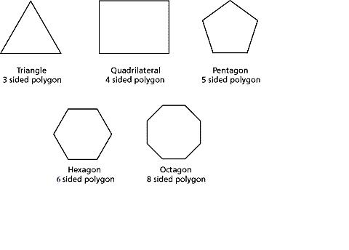
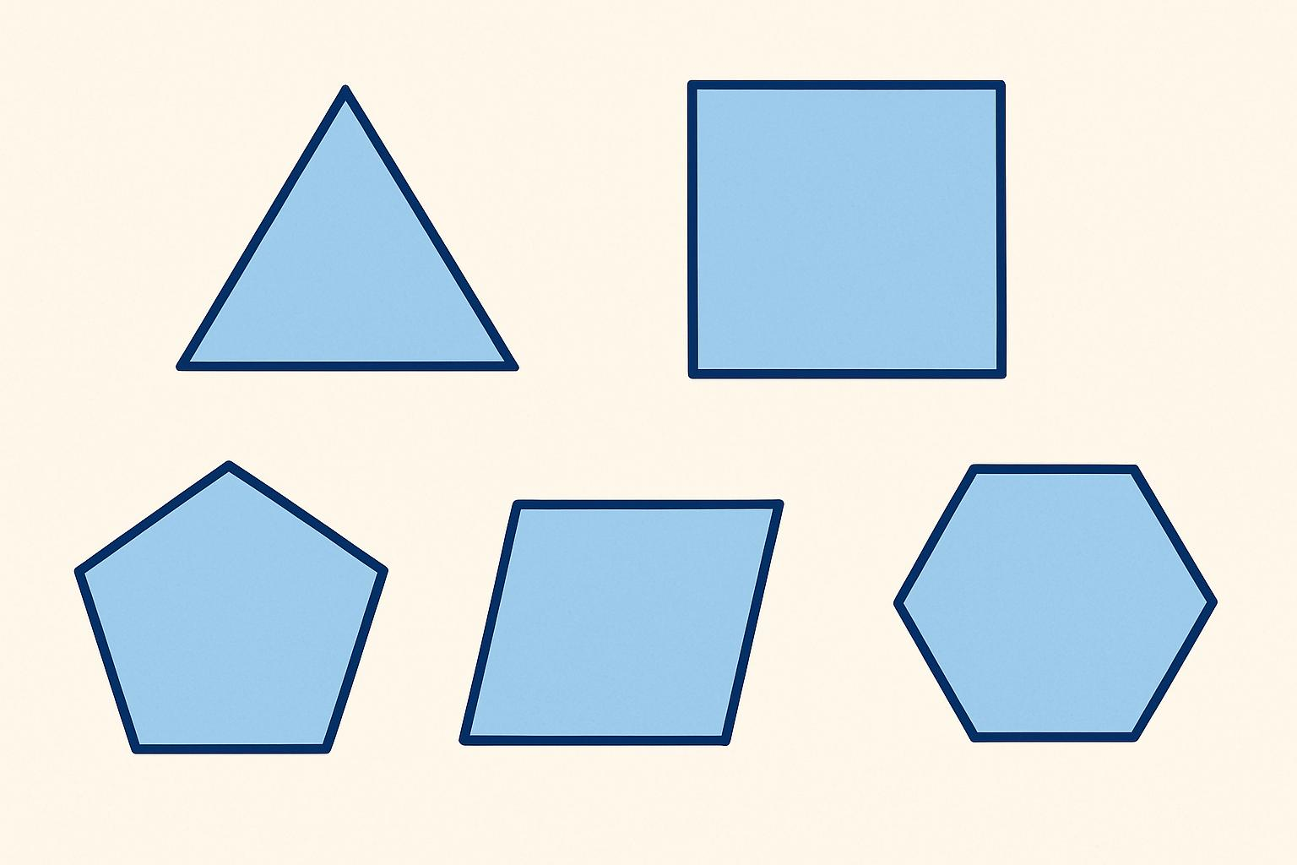
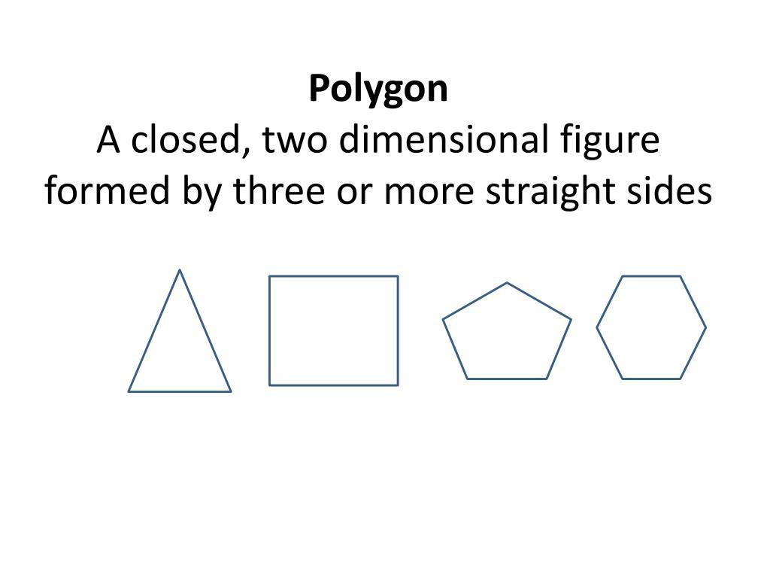
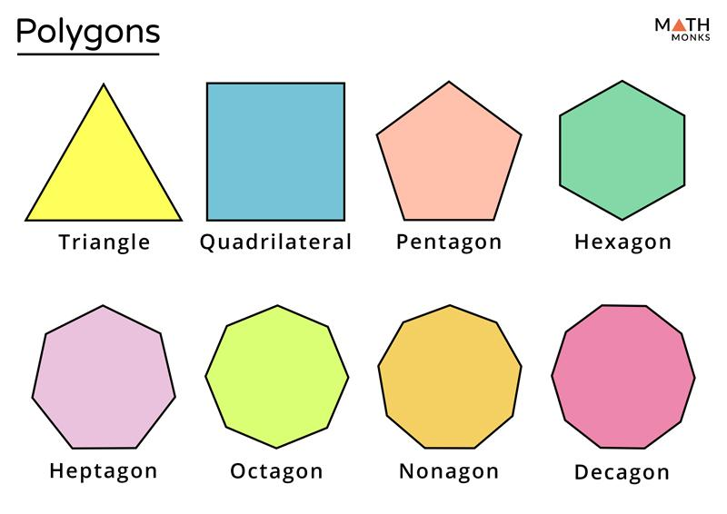

Definition
# Source: AI Source: Provided by: [Data Path: Persons Table -> ID Column: 1, Name_En Column: Motasem Essam] -> From: [ChatGPT] on [7/25/2026]
A Closed Polygonal Shape is a closed plane shape whose boundary is made entirely of straight line segments connected end-to-end.
In simple terms:
A closed polygonal shape is a closed shape made only from straight sides.
$$\boxed{\text{Closed Polygonal Shape}=\text{Closed}+\text{Straight Boundaries}+\text{Connected Vertices}}$$

Characteristics
# Source: AI Source: Provided by: [Data Path: Persons Table -> ID Column: 1, Name_En Column: Motasem Essam] -> From: [ChatGPT] on [7/25/2026]
A closed polygonal shape:
- Is closed.
- Has no open endpoints.
- Is made entirely of straight line segments.
- Has vertices where its sides meet.
- Encloses a bounded region.
- Has a finite number of sides.
- Has an interior and an exterior.
- Can be classified according to its number of sides.
- May be regular or irregular.
- May be convex or concave.

Types by Number of Sides

1. Triangle
# Source: AI Source: Provided by: [Data Path: Persons Table -> ID Column: 1, Name_En Column: Motasem Essam] -> From: [ChatGPT] on [7/25/2026]
A polygon with 3 sides and 3 vertices.
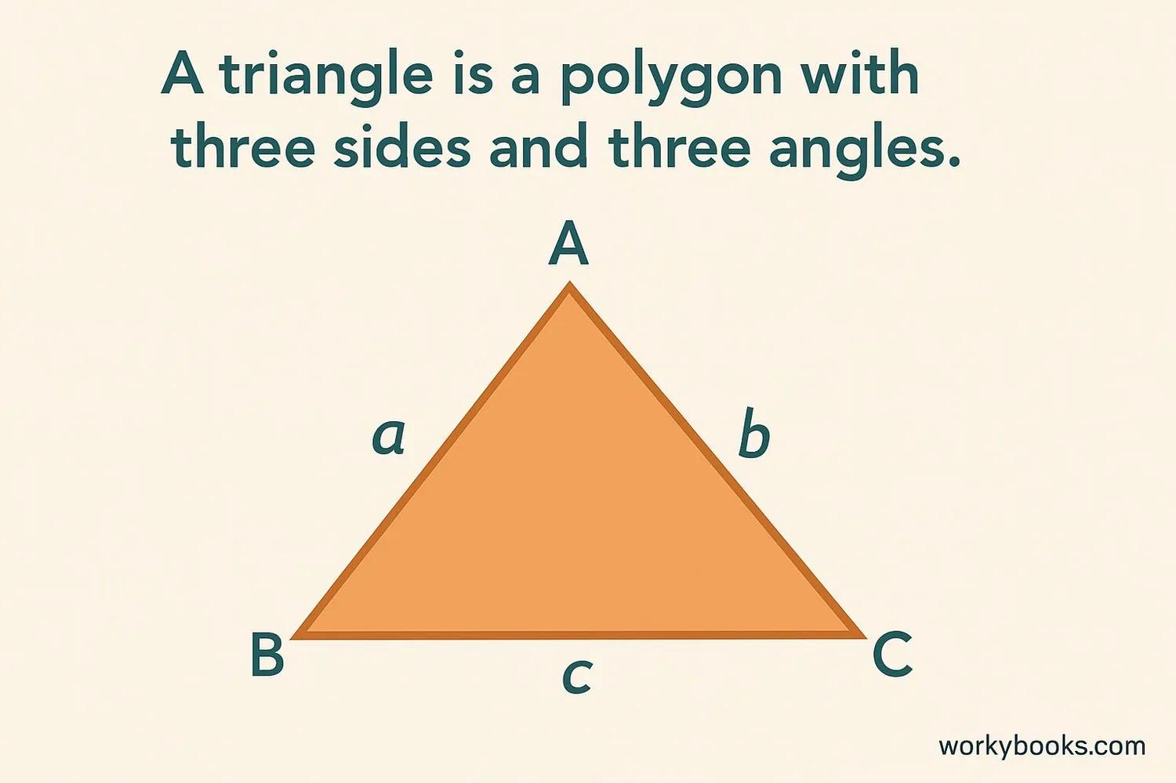
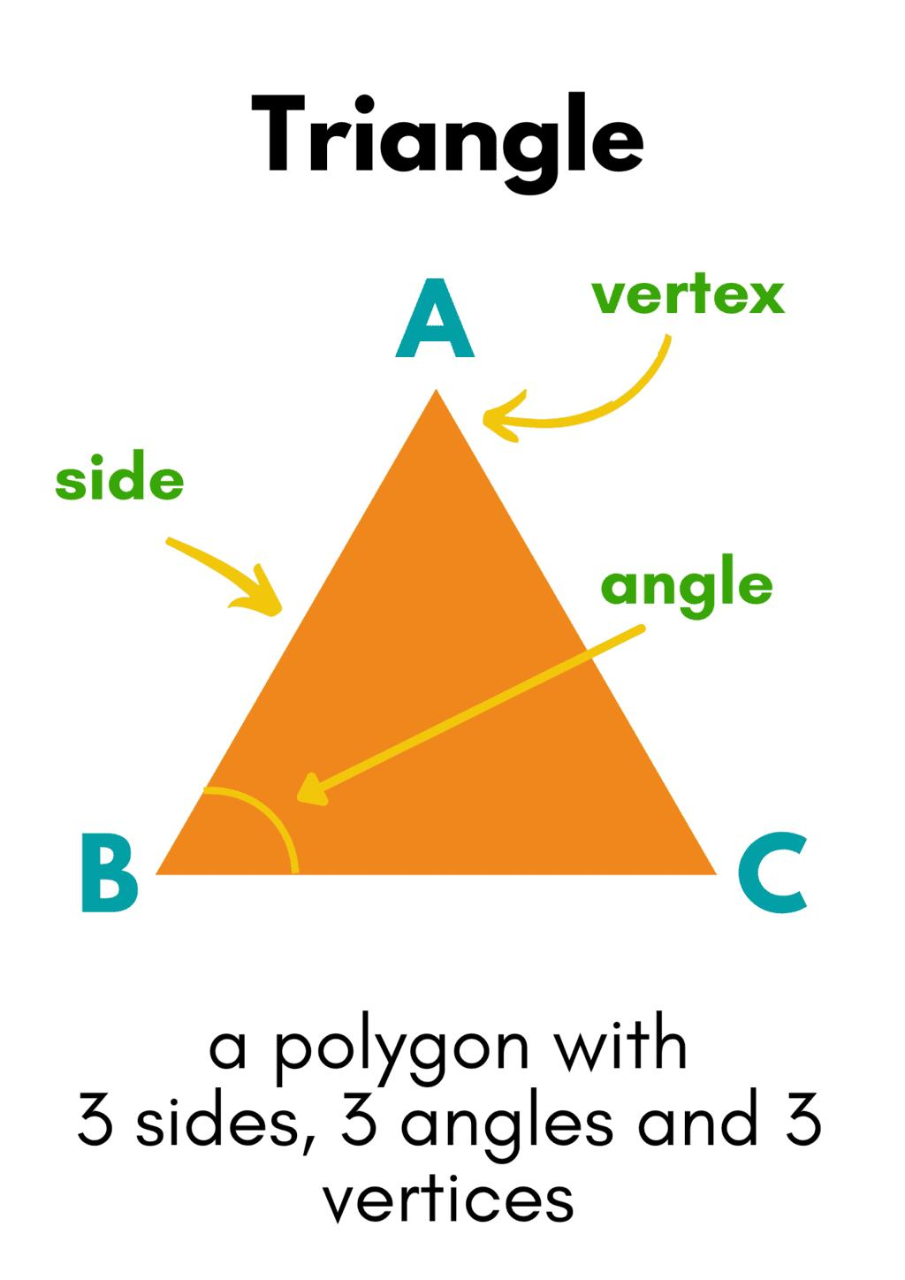
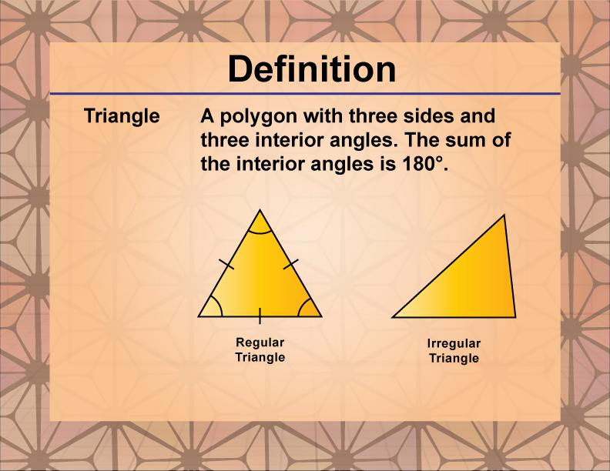
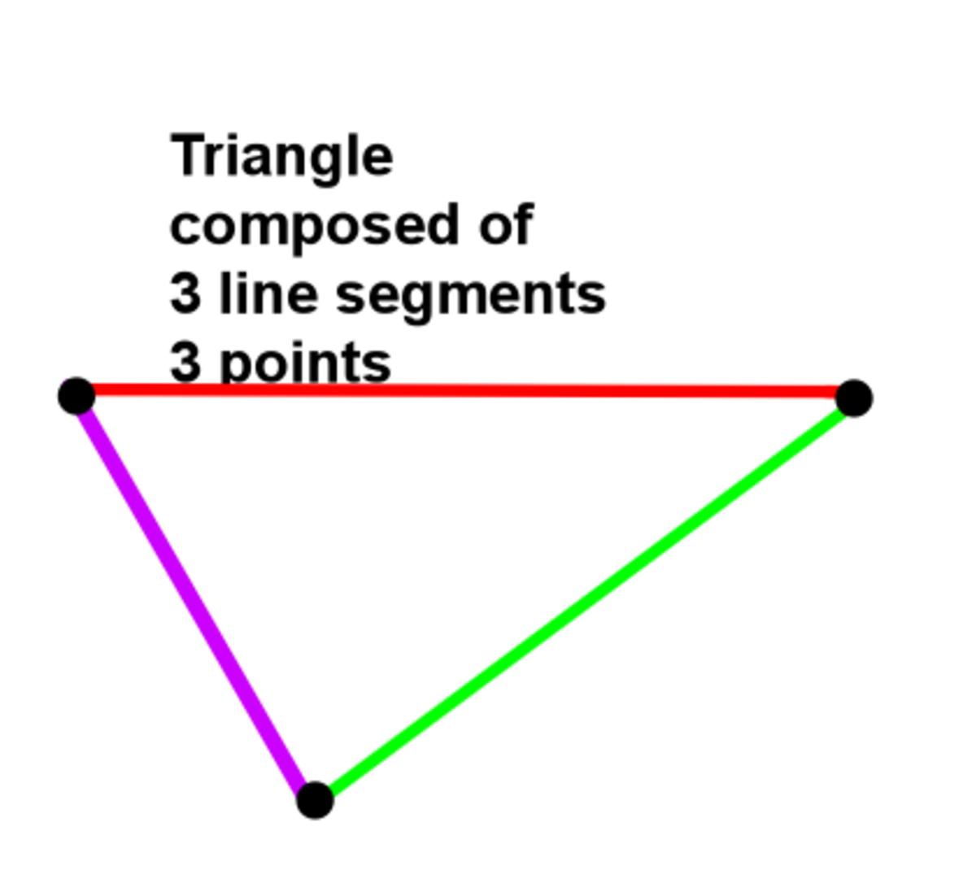
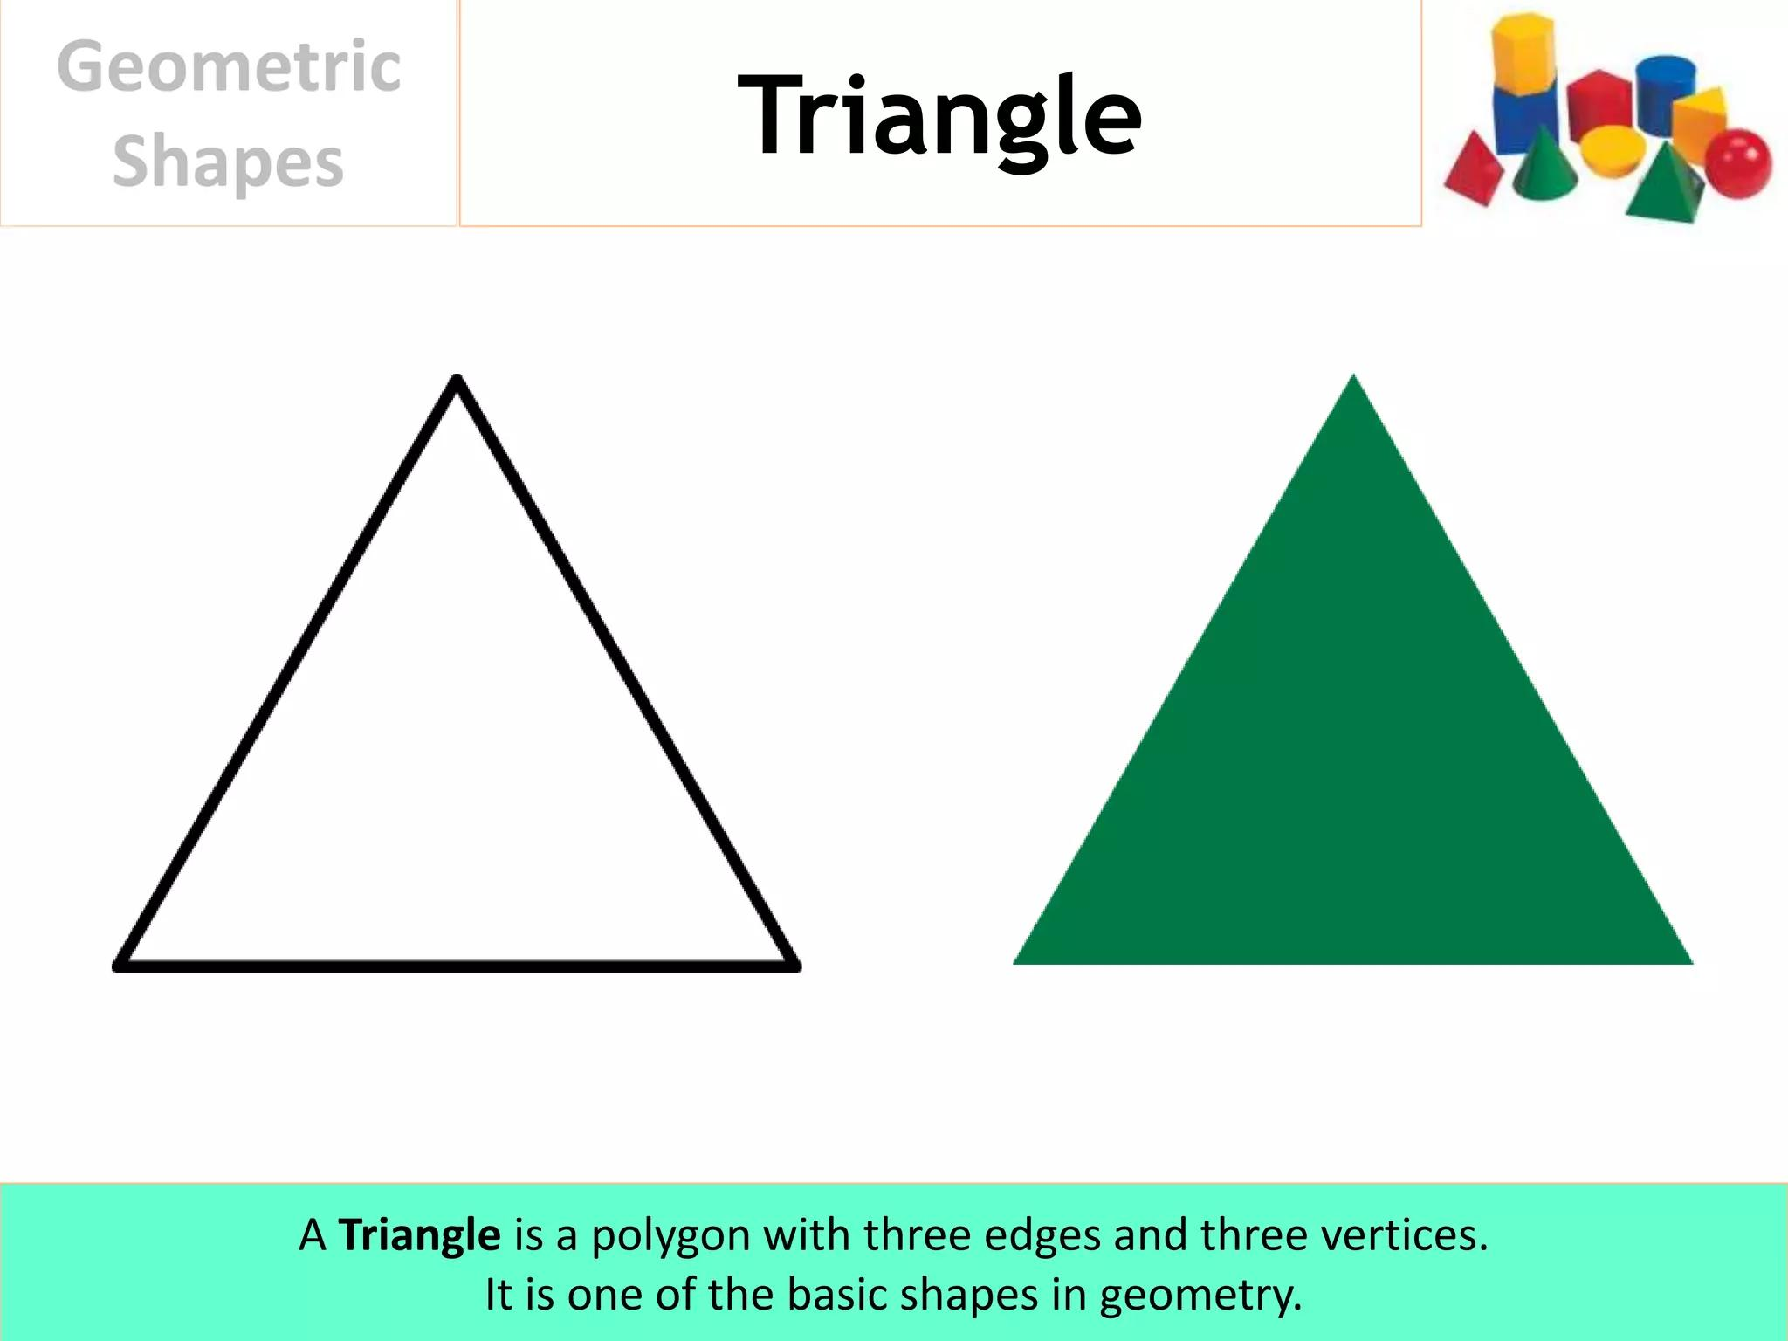
$$\boxed{n=3}$$
Examples include:
- Equilateral triangle
- Isosceles triangle
- Scalene triangle

2. Quadrilateral
# Source: AI Source: Provided by: [Data Path: Persons Table -> ID Column: 1, Name_En Column: Motasem Essam] -> From: [ChatGPT] on [7/25/2026]
A polygon with 4 sides and 4 vertices.
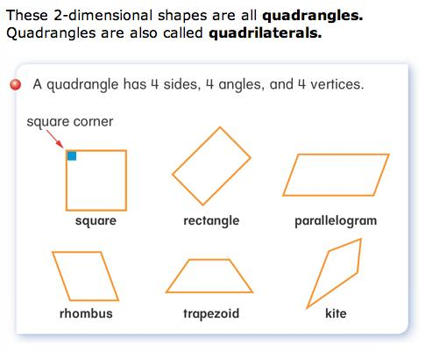
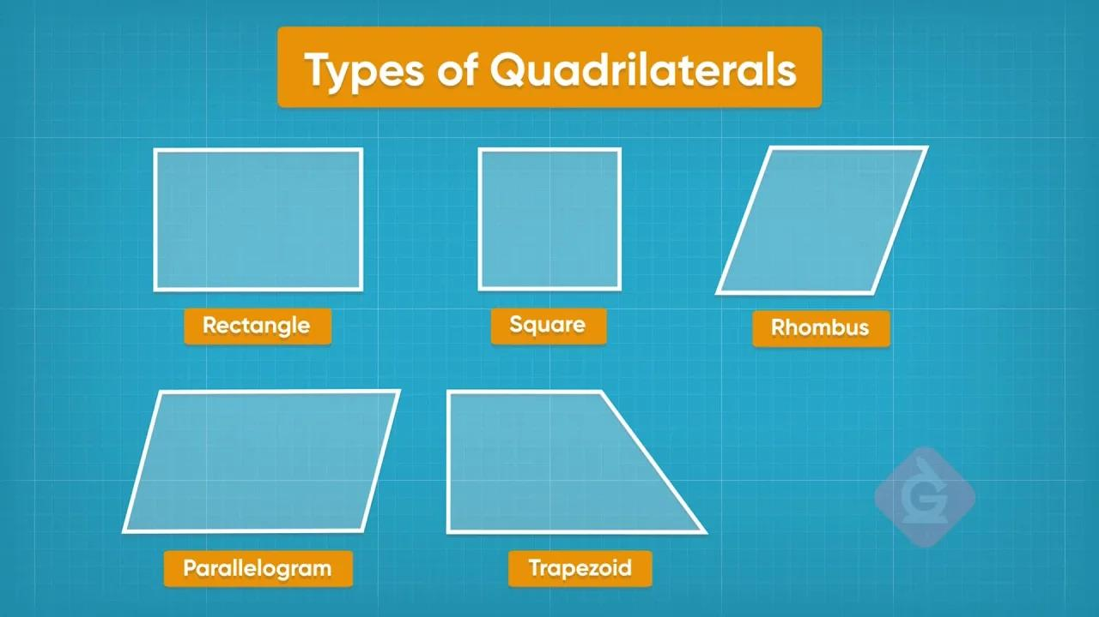
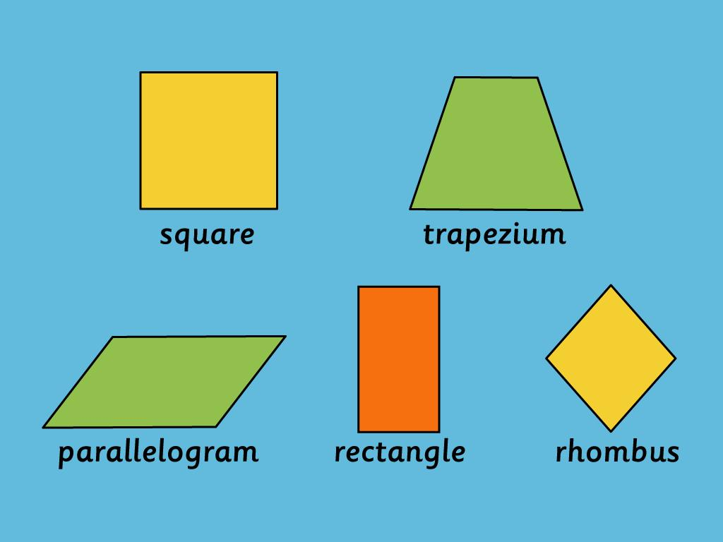
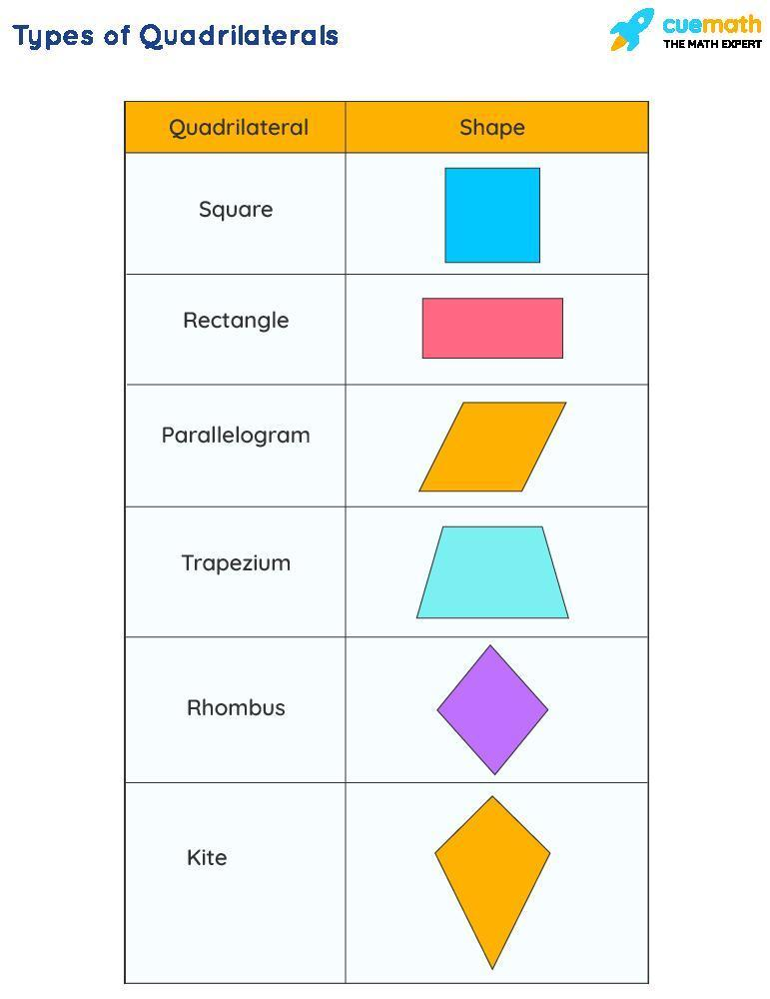
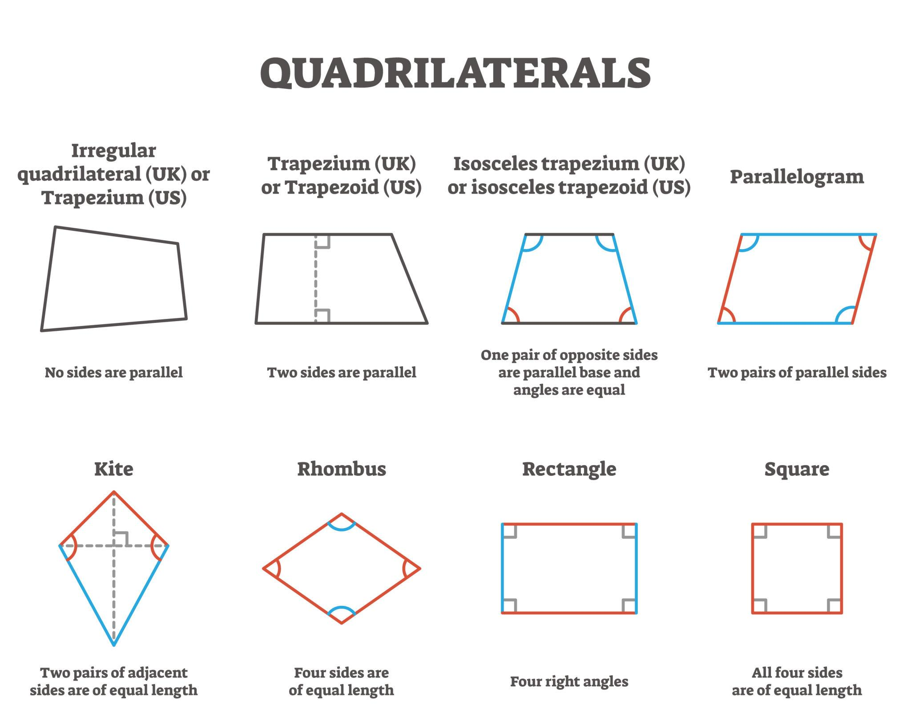
$$\boxed{n=4}$$
Examples include:
- Square
- Rectangle
- Rhombus
- Parallelogram
- Trapezoid
- Kite

3. Pentagon
# Source: AI Source: Provided by: [Data Path: Persons Table -> ID Column: 1, Name_En Column: Motasem Essam] -> From: [ChatGPT] on [7/25/2026]
A polygon with 5 sides and 5 vertices.
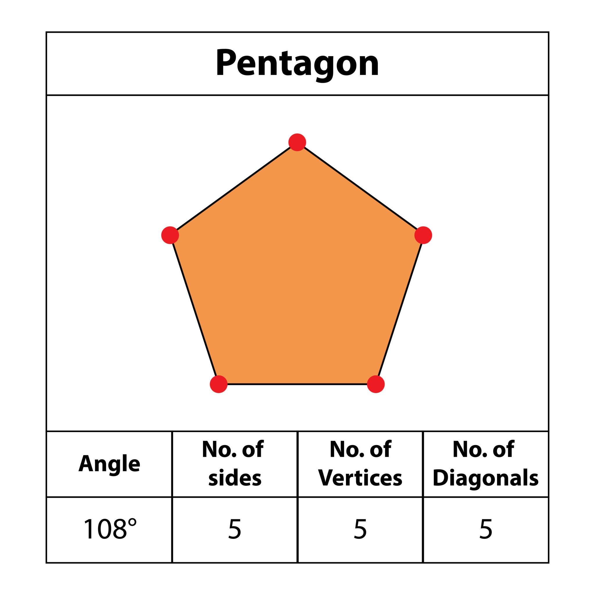
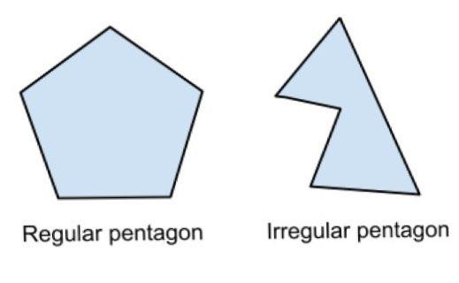
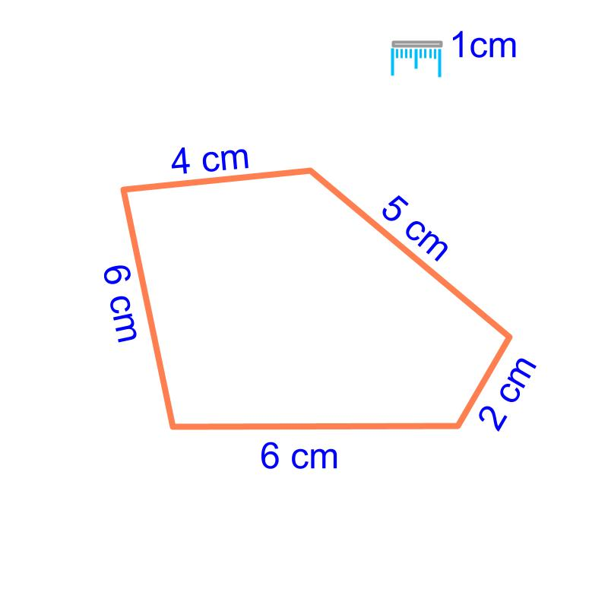
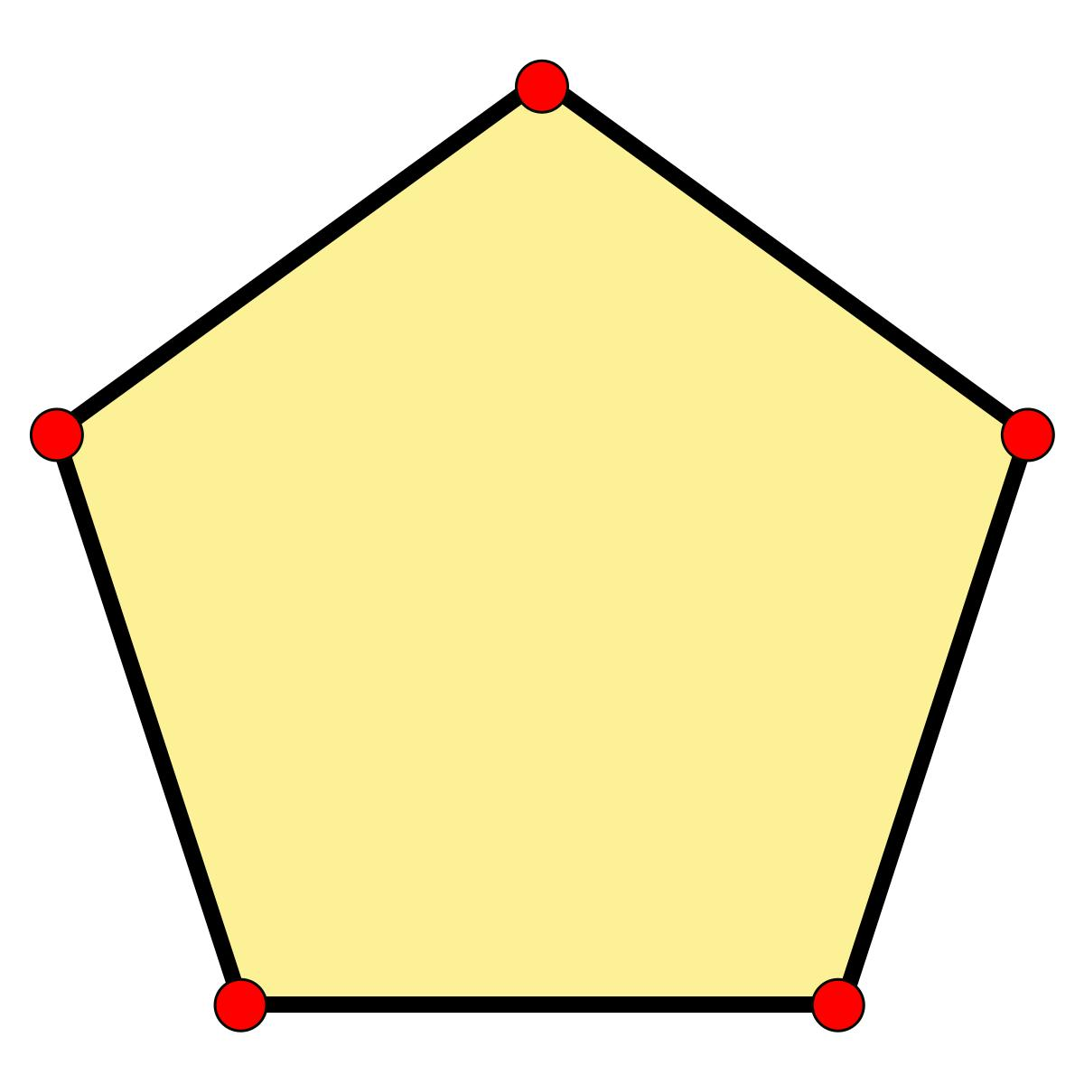
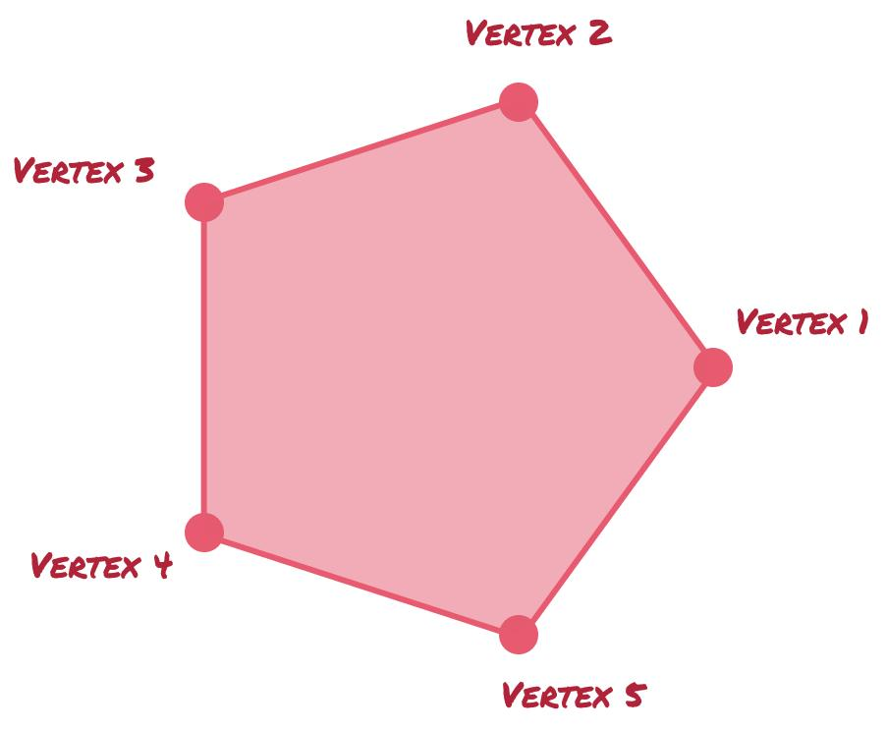
$$\boxed{n=5}$$

4. Hexagon
# Source: AI Source: Provided by: [Data Path: Persons Table -> ID Column: 1, Name_En Column: Motasem Essam] -> From: [ChatGPT] on [7/25/2026]
A polygon with 6 sides and 6 vertices.
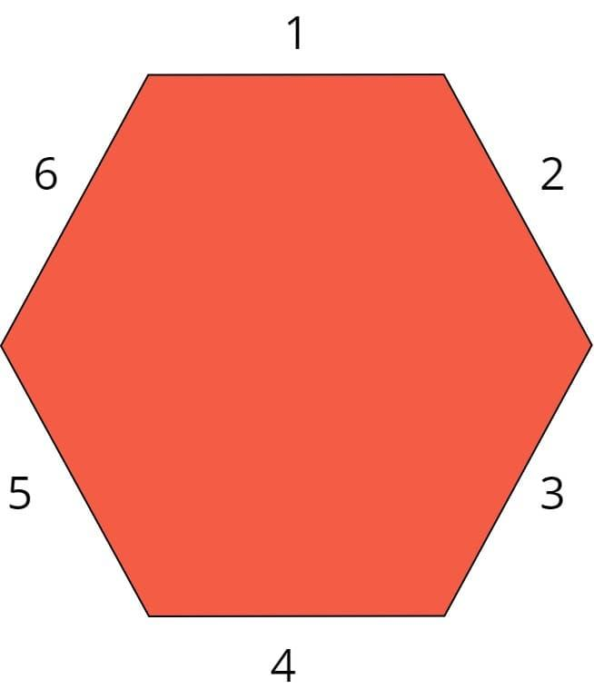
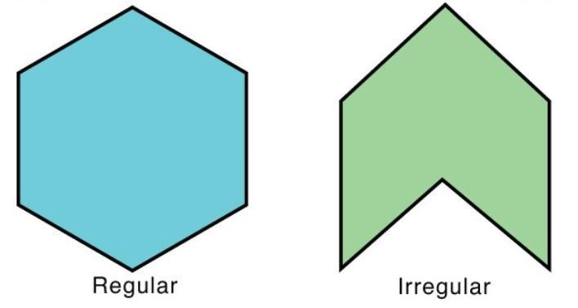
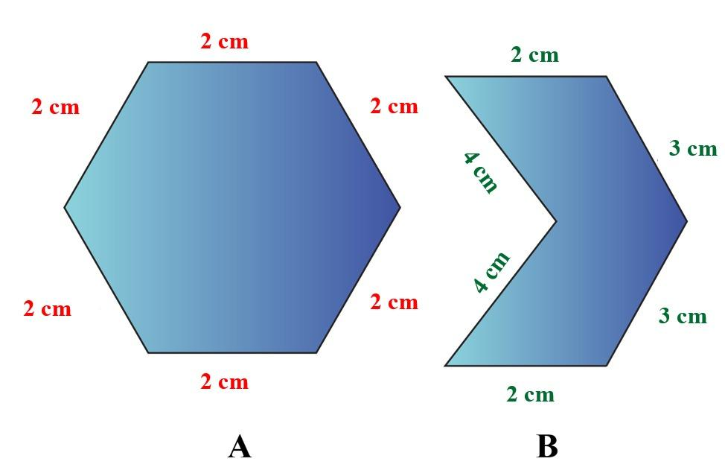
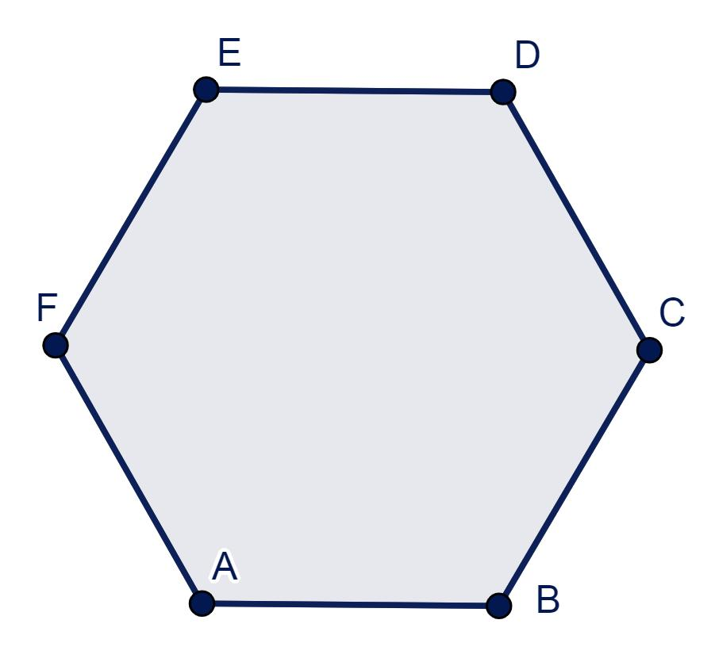
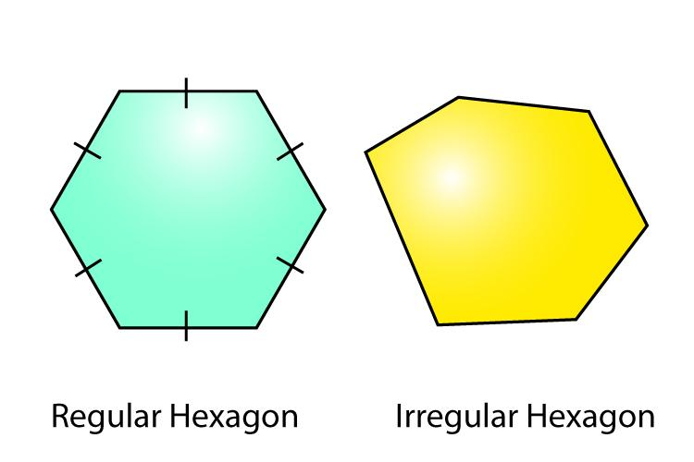
$$\boxed{n=6}$$

5. Heptagon
# Source: AI Source: Provided by: [Data Path: Persons Table -> ID Column: 1, Name_En Column: Motasem Essam] -> From: [ChatGPT] on [7/25/2026]
A polygon with 7 sides and 7 vertices.
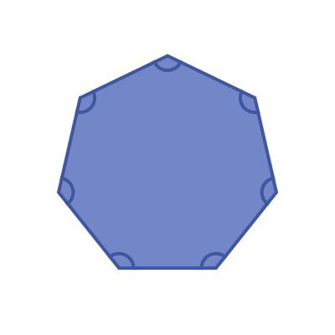
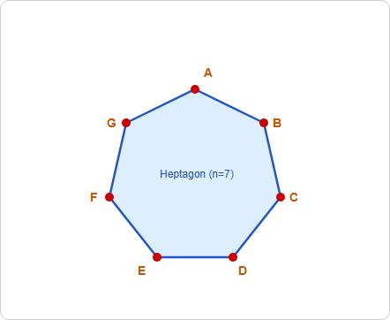
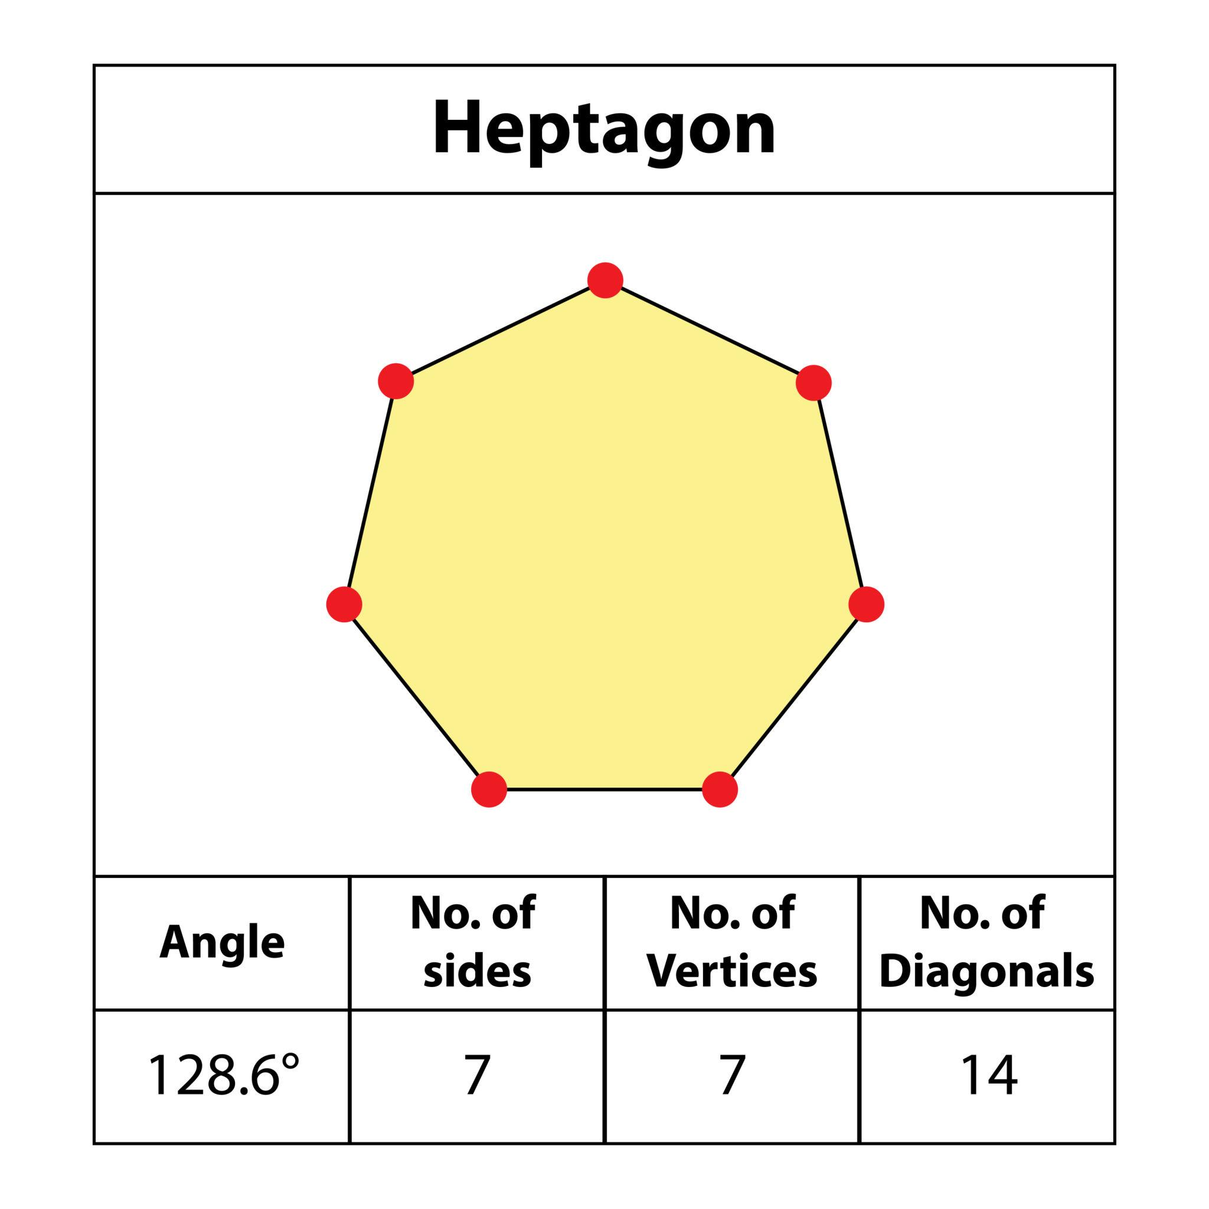
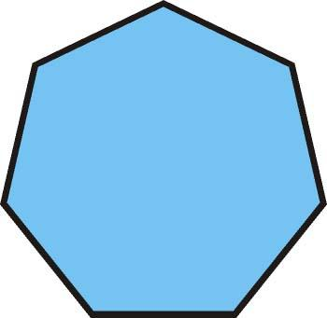
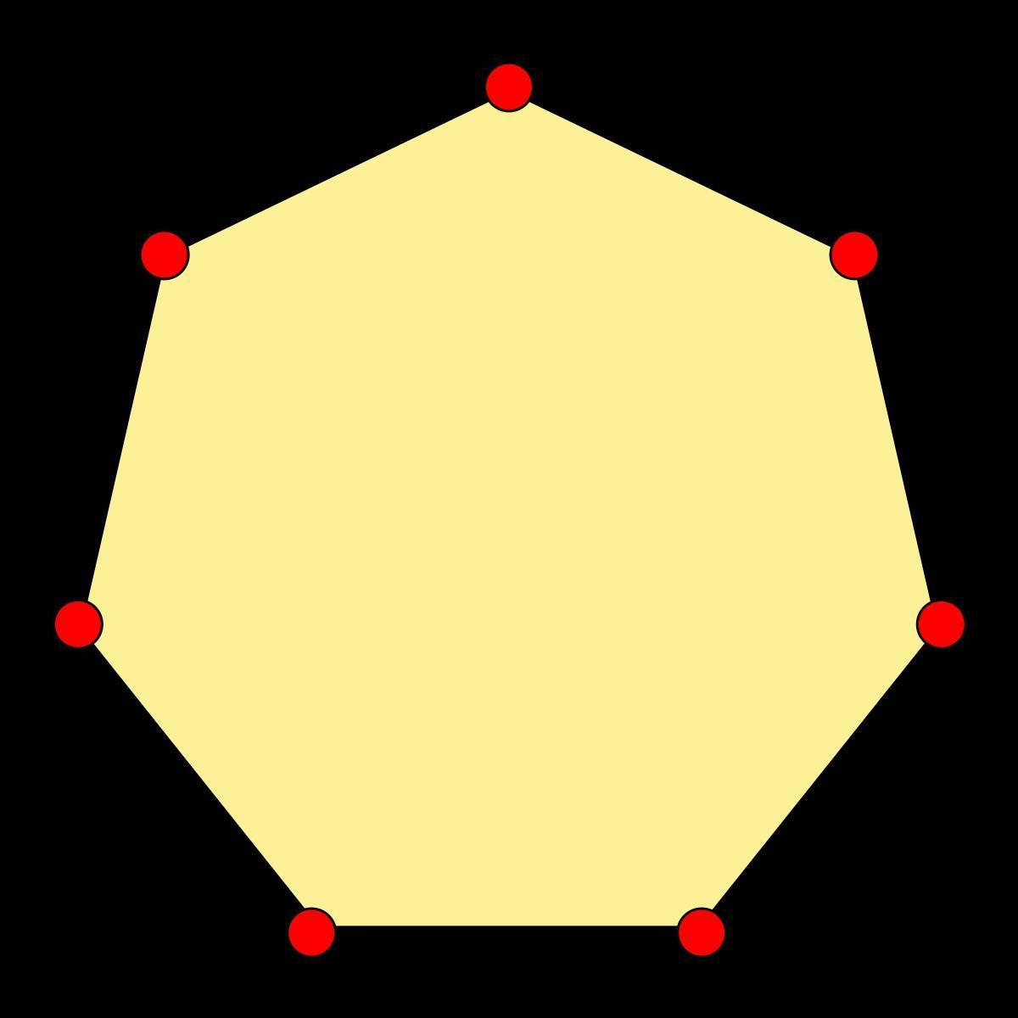
$$\boxed{n=7}$$

6. Octagon
# Source: AI Source: Provided by: [Data Path: Persons Table -> ID Column: 1, Name_En Column: Motasem Essam] -> From: [ChatGPT] on [7/25/2026]
A polygon with 8 sides and 8 vertices.
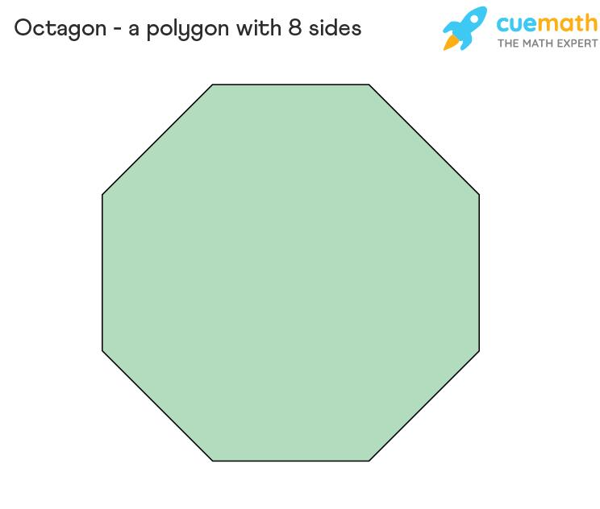
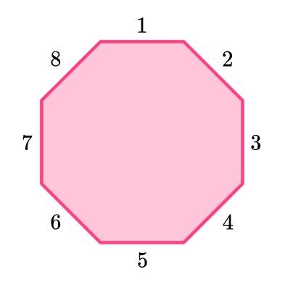
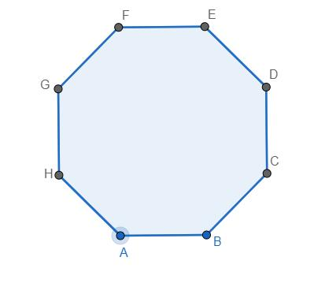
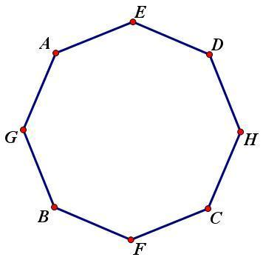
$$\boxed{n=8}$$

7. Nonagon
# Source: AI Source: Provided by: [Data Path: Persons Table -> ID Column: 1, Name_En Column: Motasem Essam] -> From: [ChatGPT] on [7/25/2026]
A polygon with 9 sides and 9 vertices.
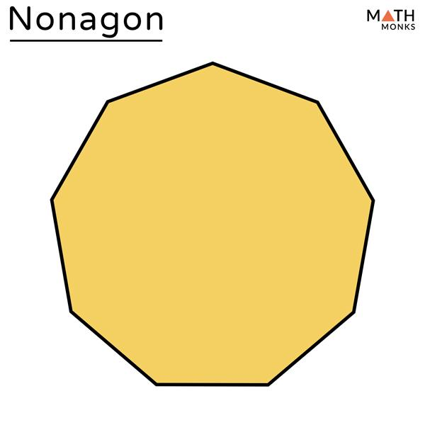
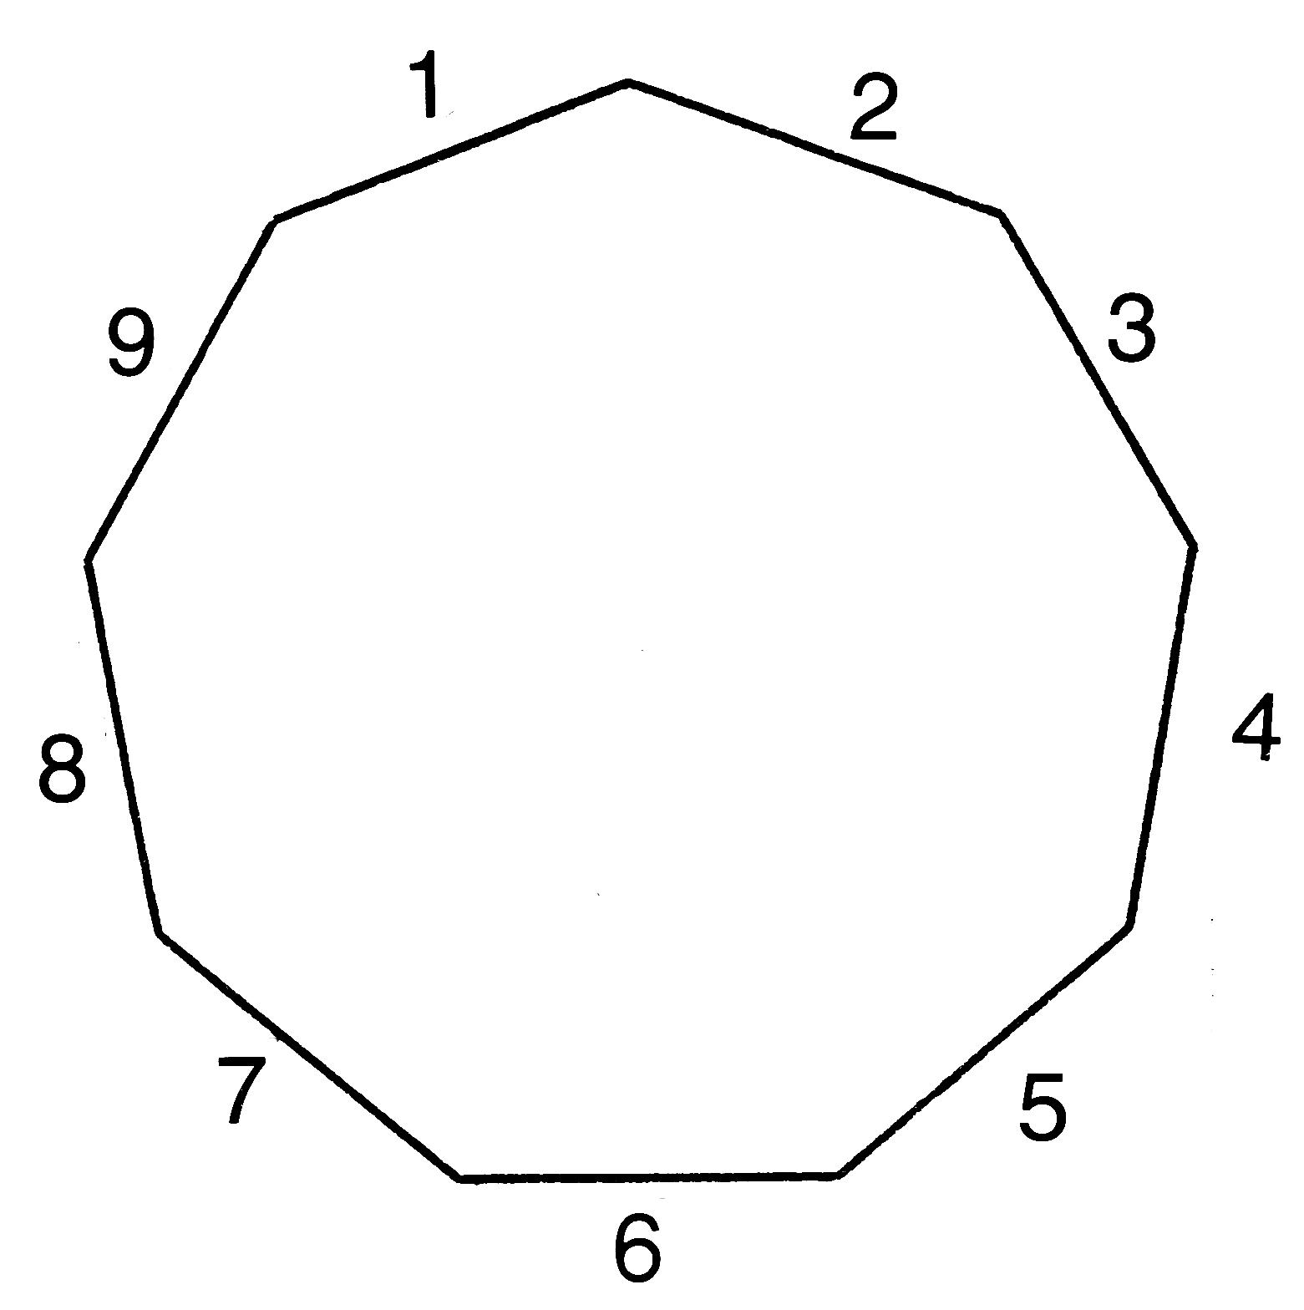
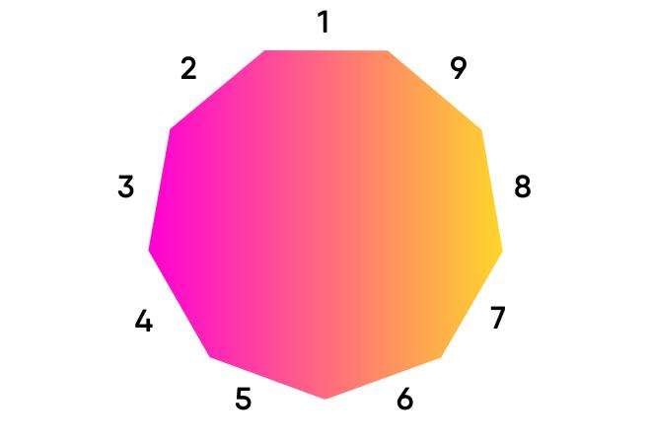
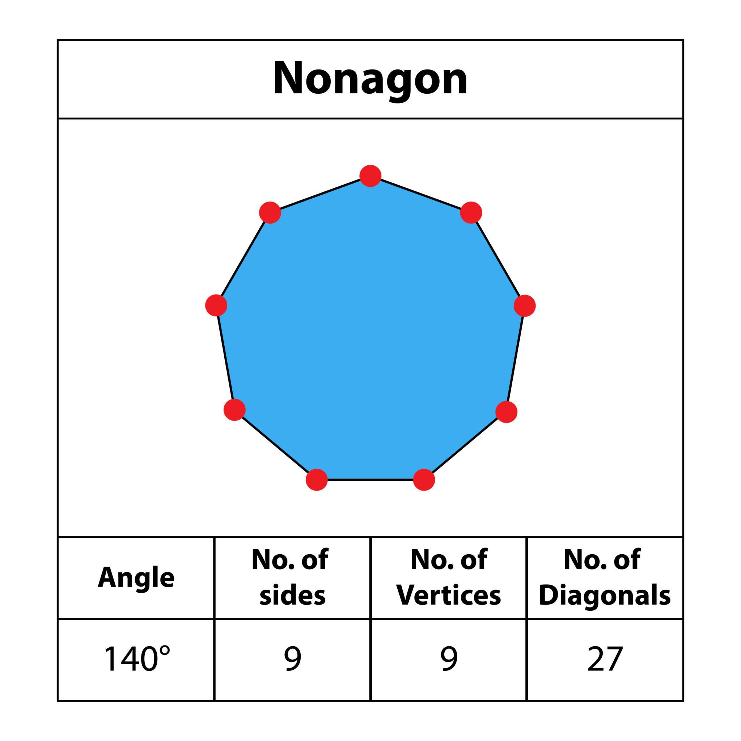
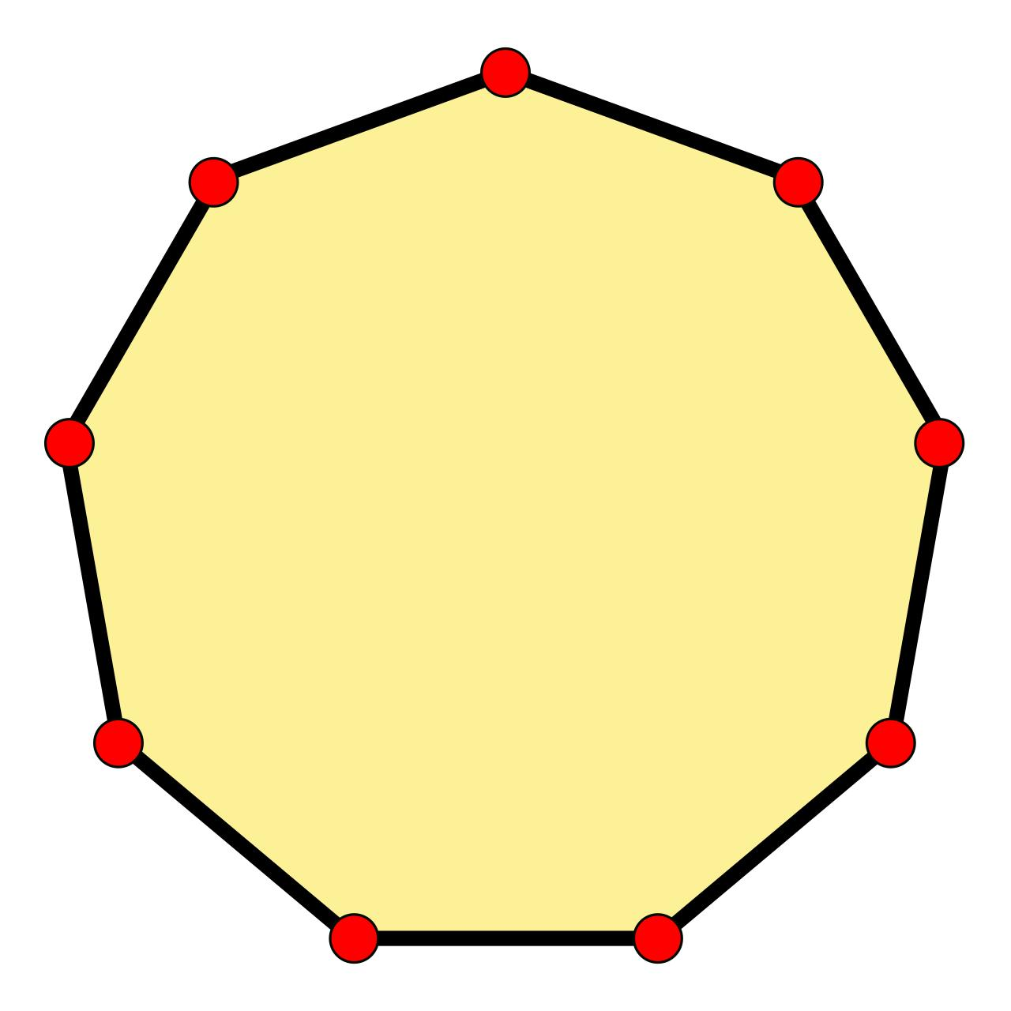
$$\boxed{n=9}$$

8. Decagon
# Source: AI Source: Provided by: [Data Path: Persons Table -> ID Column: 1, Name_En Column: Motasem Essam] -> From: [ChatGPT] on [7/25/2026]
A polygon with 10 sides and 10 vertices.
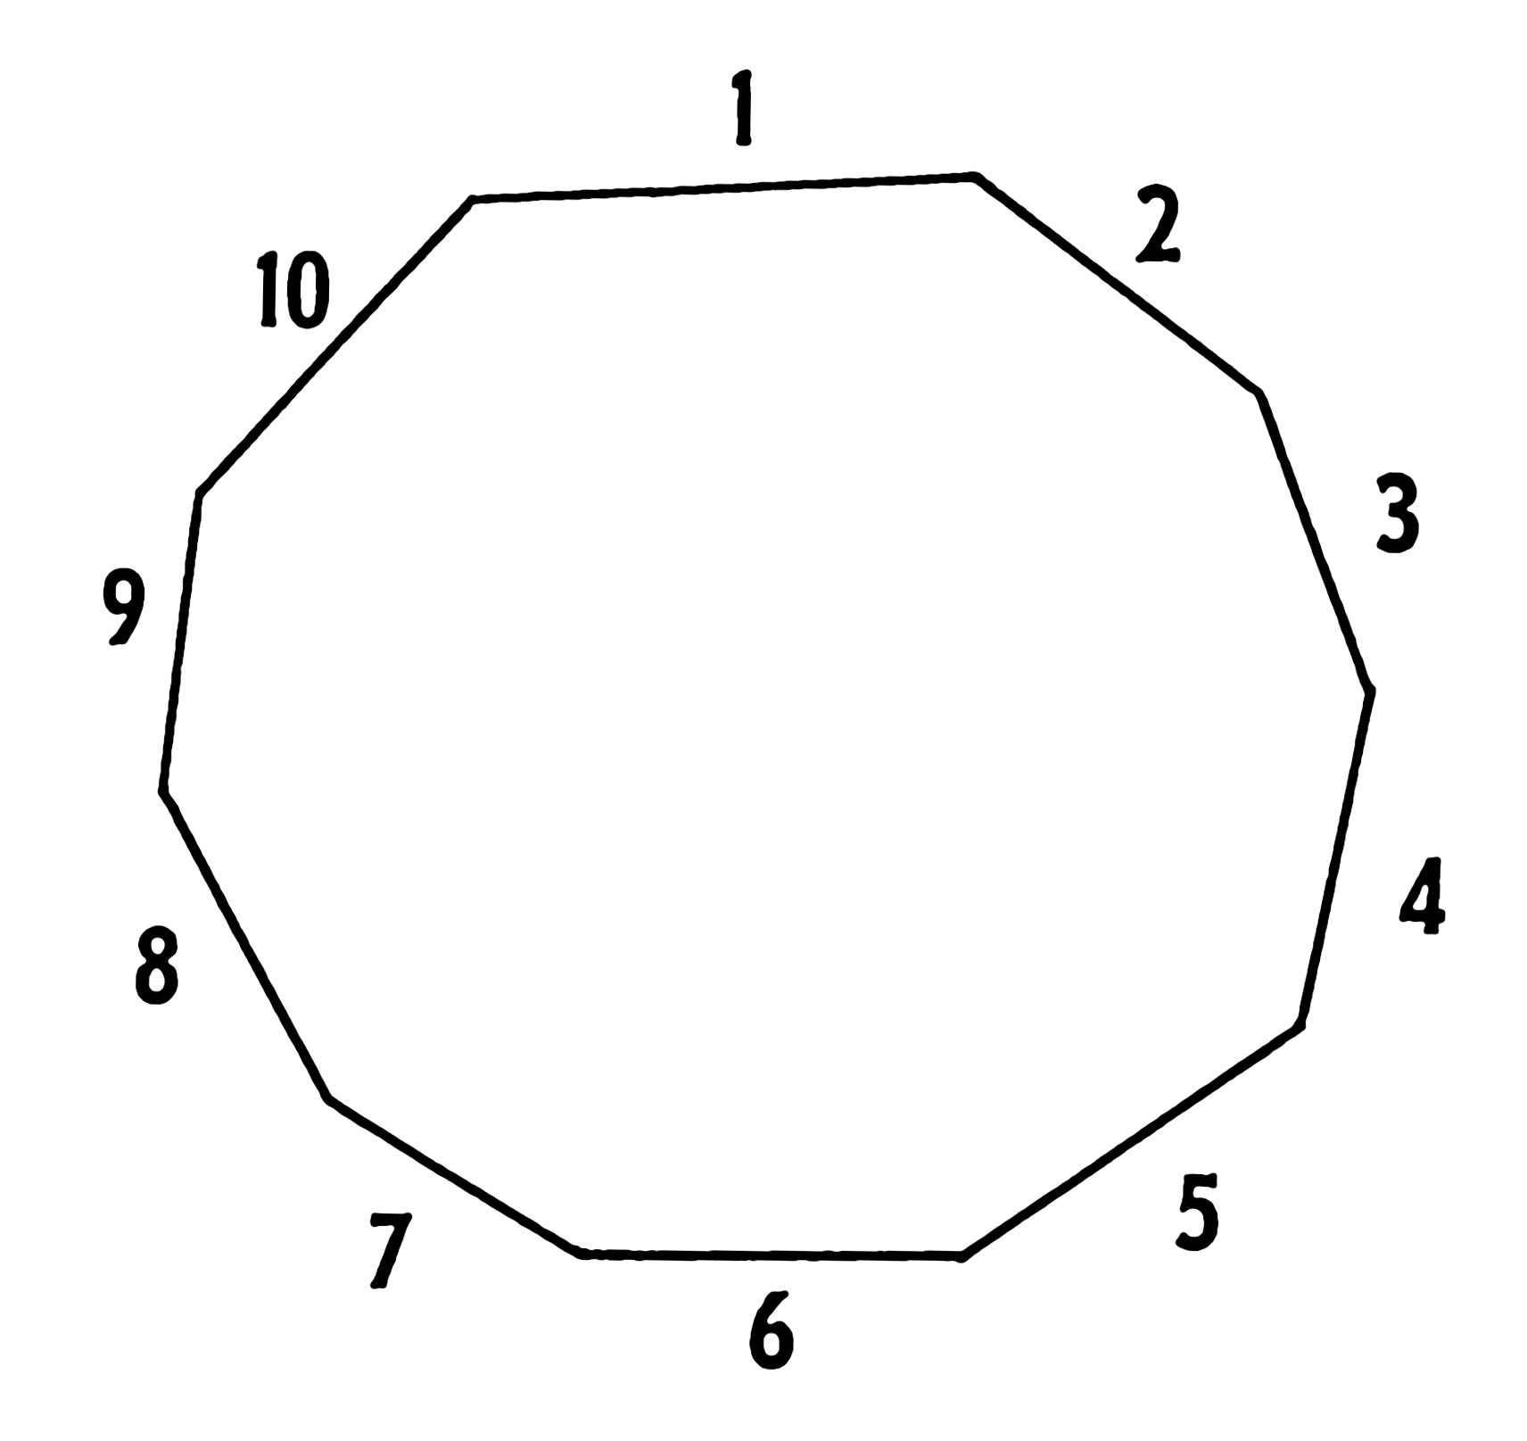
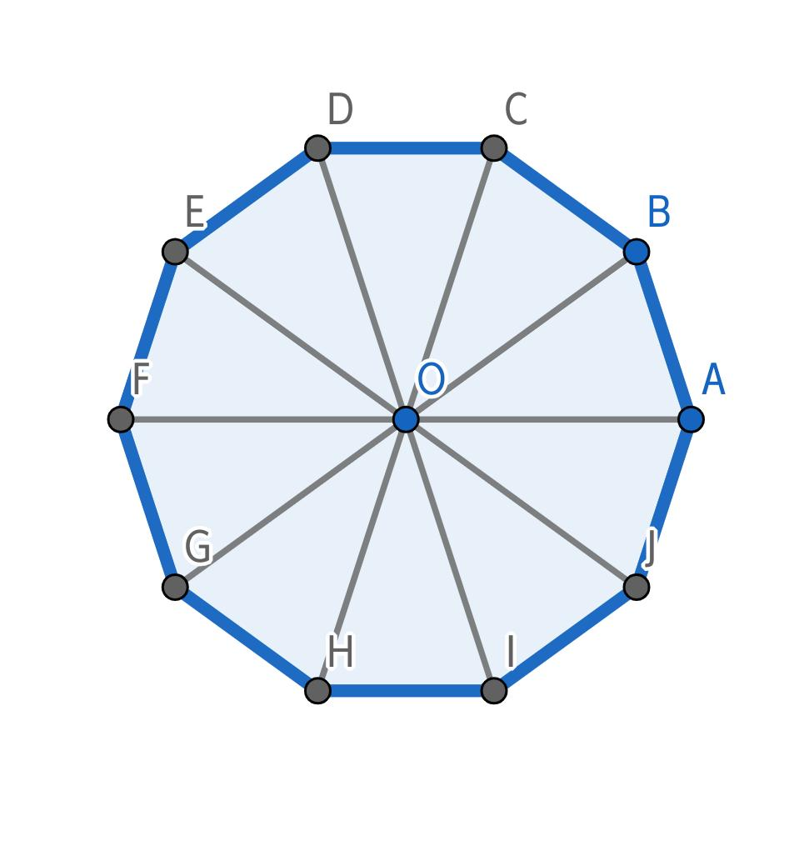
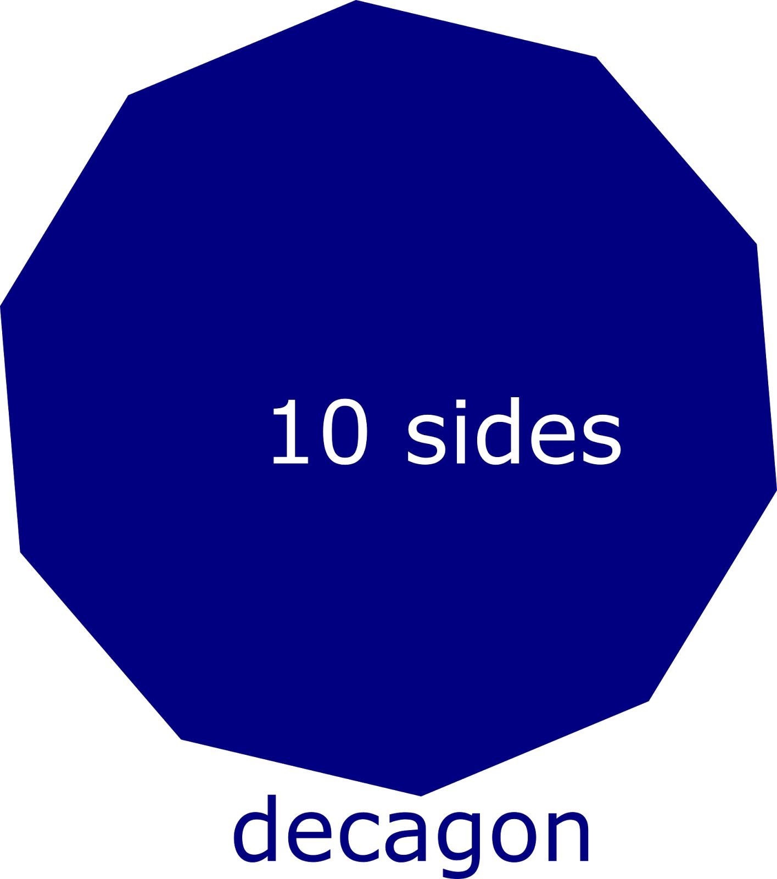
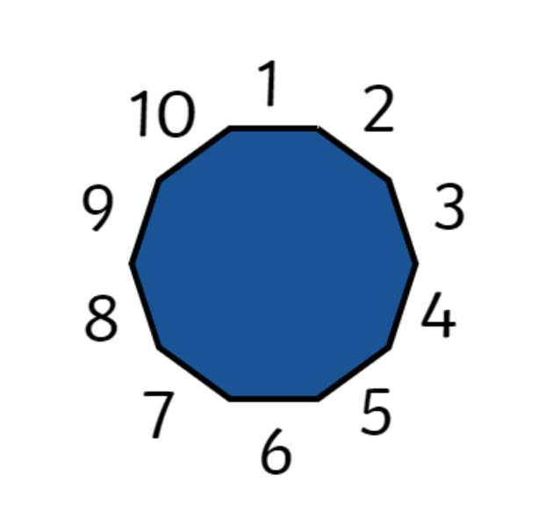
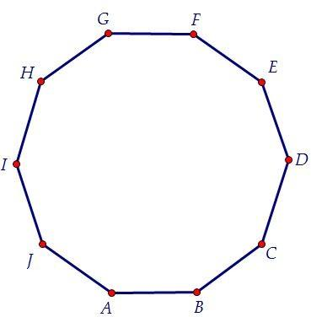
$$\boxed{n=10}$$

Classification by Regularity
Closed polygonal shapes can also be classified as regular or irregular.

Regular Closed Polygonal Shapes
# Source: AI Source: Provided by: [Data Path: Persons Table -> ID Column: 1, Name_En Column: Motasem Essam] -> From: [ChatGPT] on [7/25/2026]
All sides and all interior angles are equal.
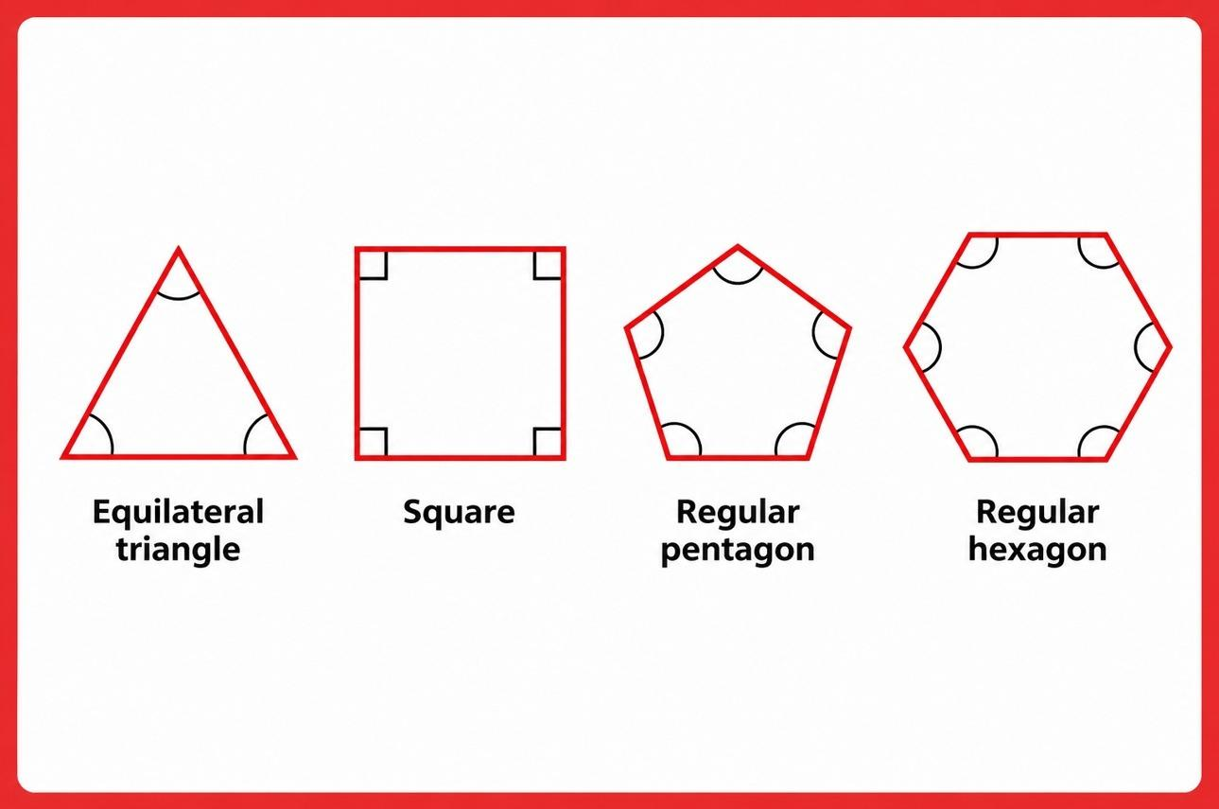
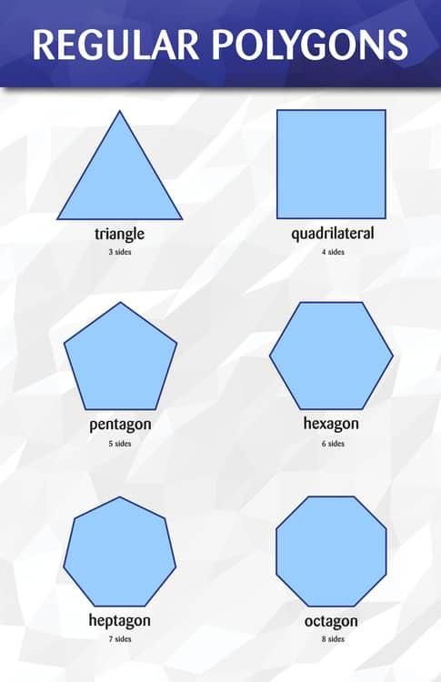
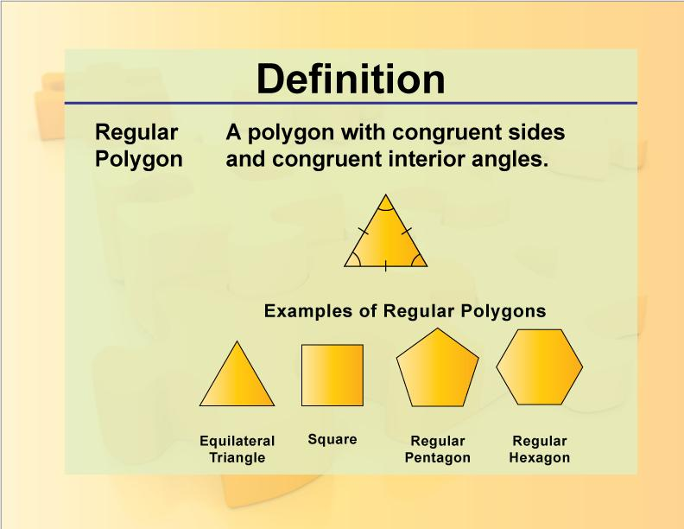
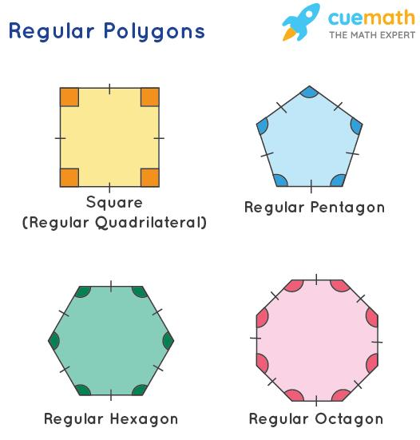
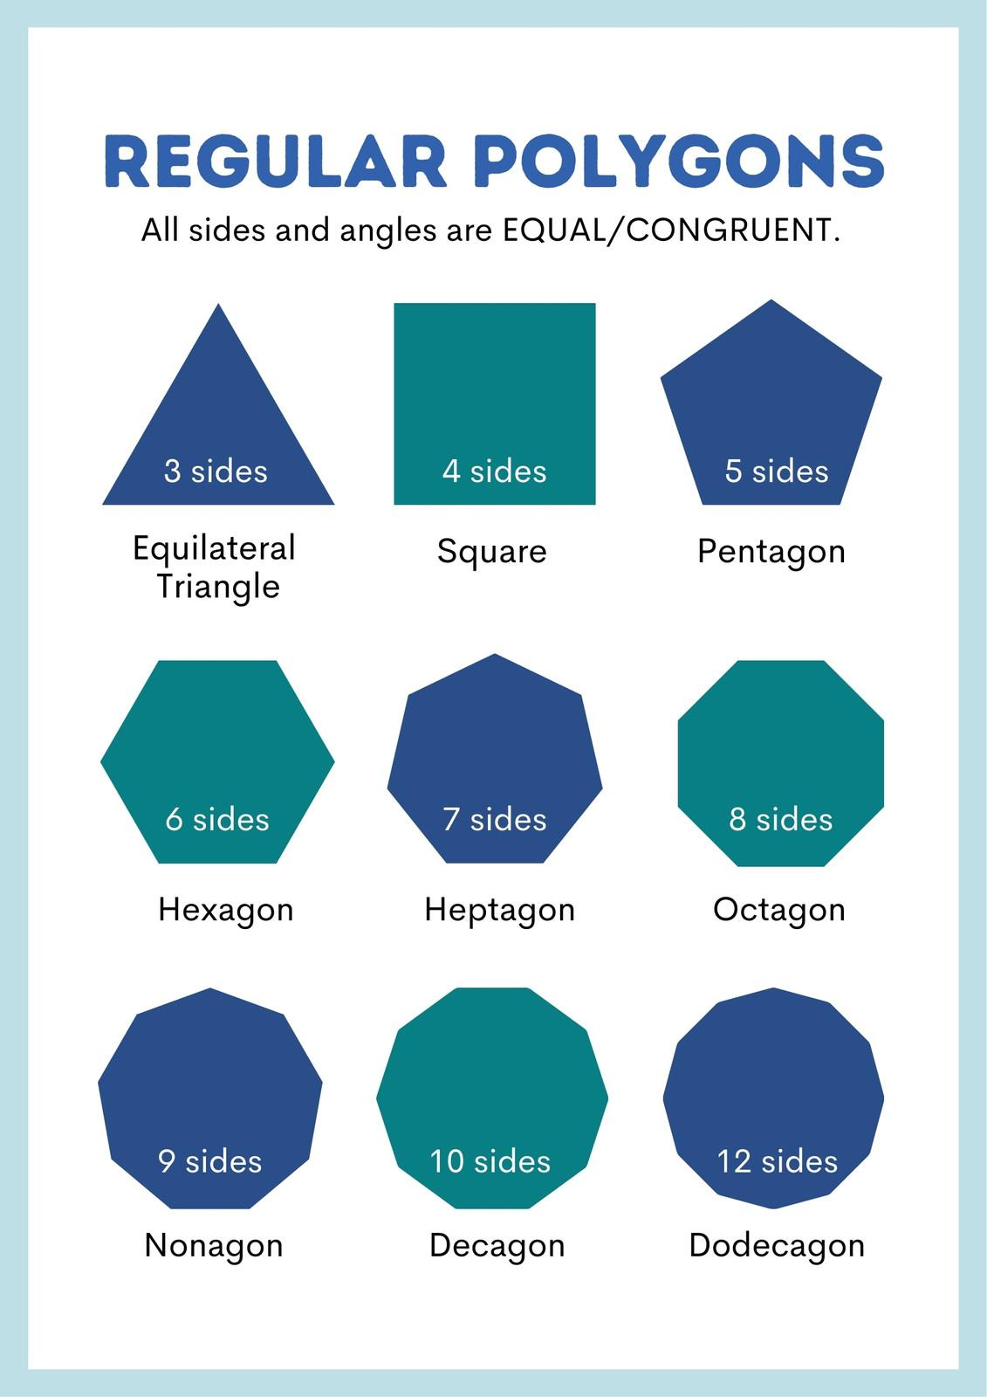
$$\boxed{\text{Equal Sides}+\text{Equal Angles}}$$
Examples:
- Equilateral triangle
- Square
- Regular pentagon
- Regular hexagon

Irregular Closed Polygonal Shapes
# Source: AI Source: Provided by: [Data Path: Persons Table -> ID Column: 1, Name_En Column: Motasem Essam] -> From: [ChatGPT] on [7/25/2026]
Their sides and/or angles are not all equal.
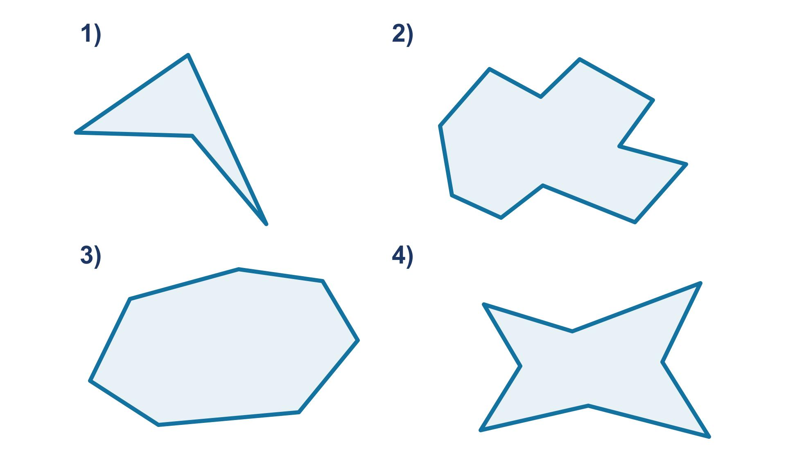
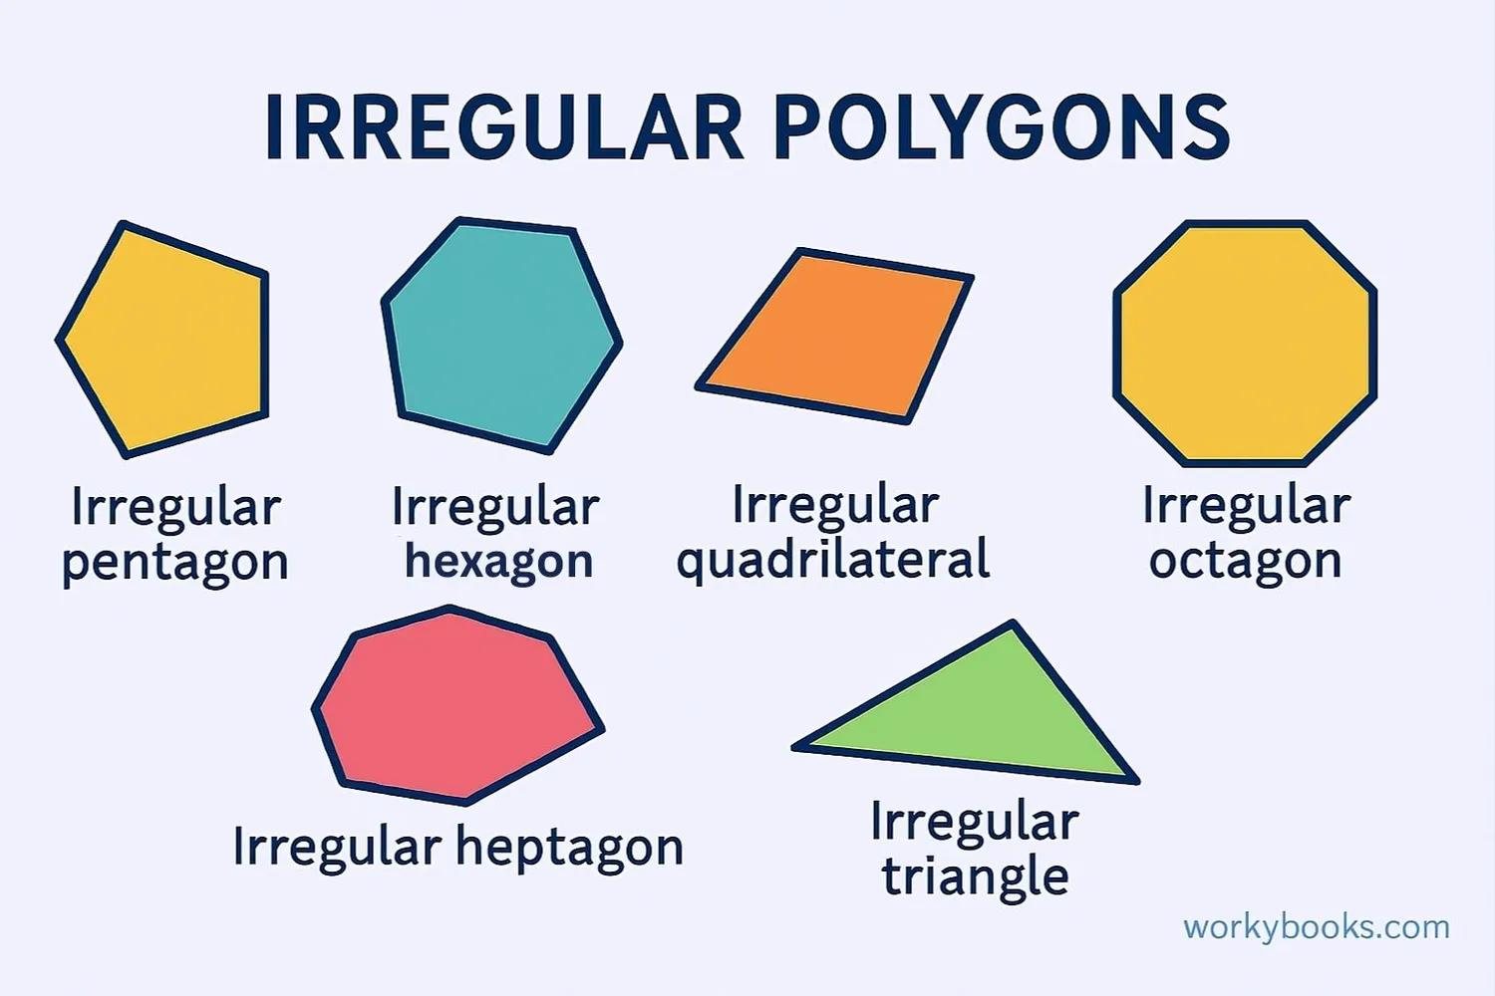
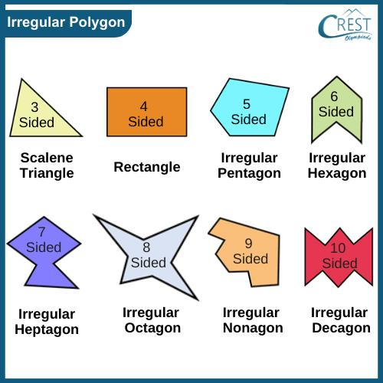
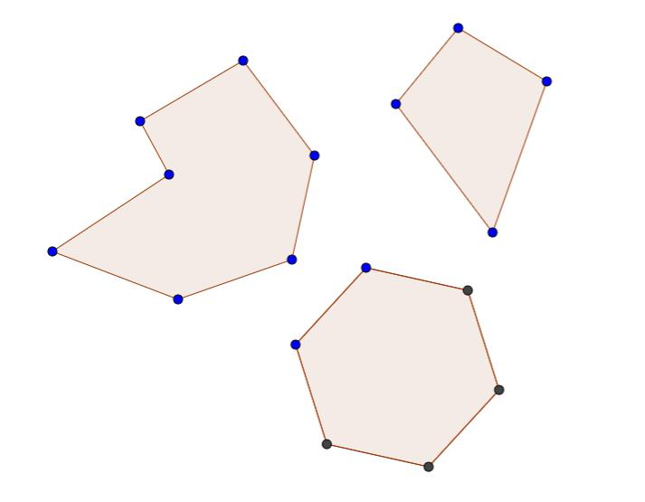
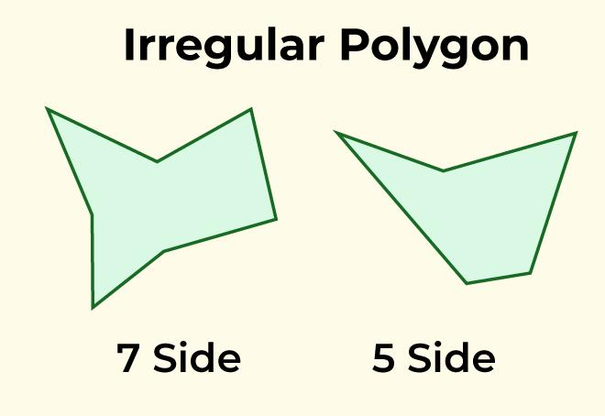
$$\boxed{\text{Not All Sides and Angles Equal}}$$

Classification by Convexity

Convex Closed Polygonal Shapes
# Source: AI Source: Provided by: [Data Path: Persons Table -> ID Column: 1, Name_En Column: Motasem Essam] -> From: [ChatGPT] on [7/25/2026]
Every interior angle is less than (180^\circ), and every segment connecting two points inside the polygon remains inside it.
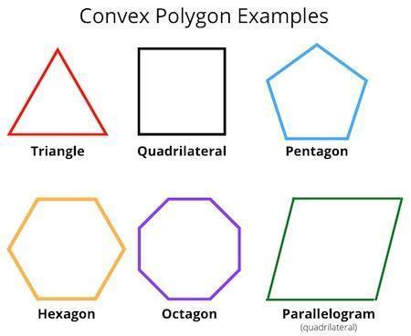
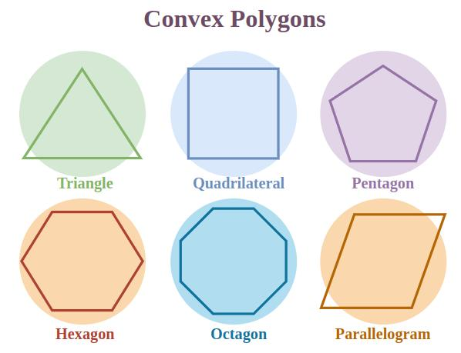
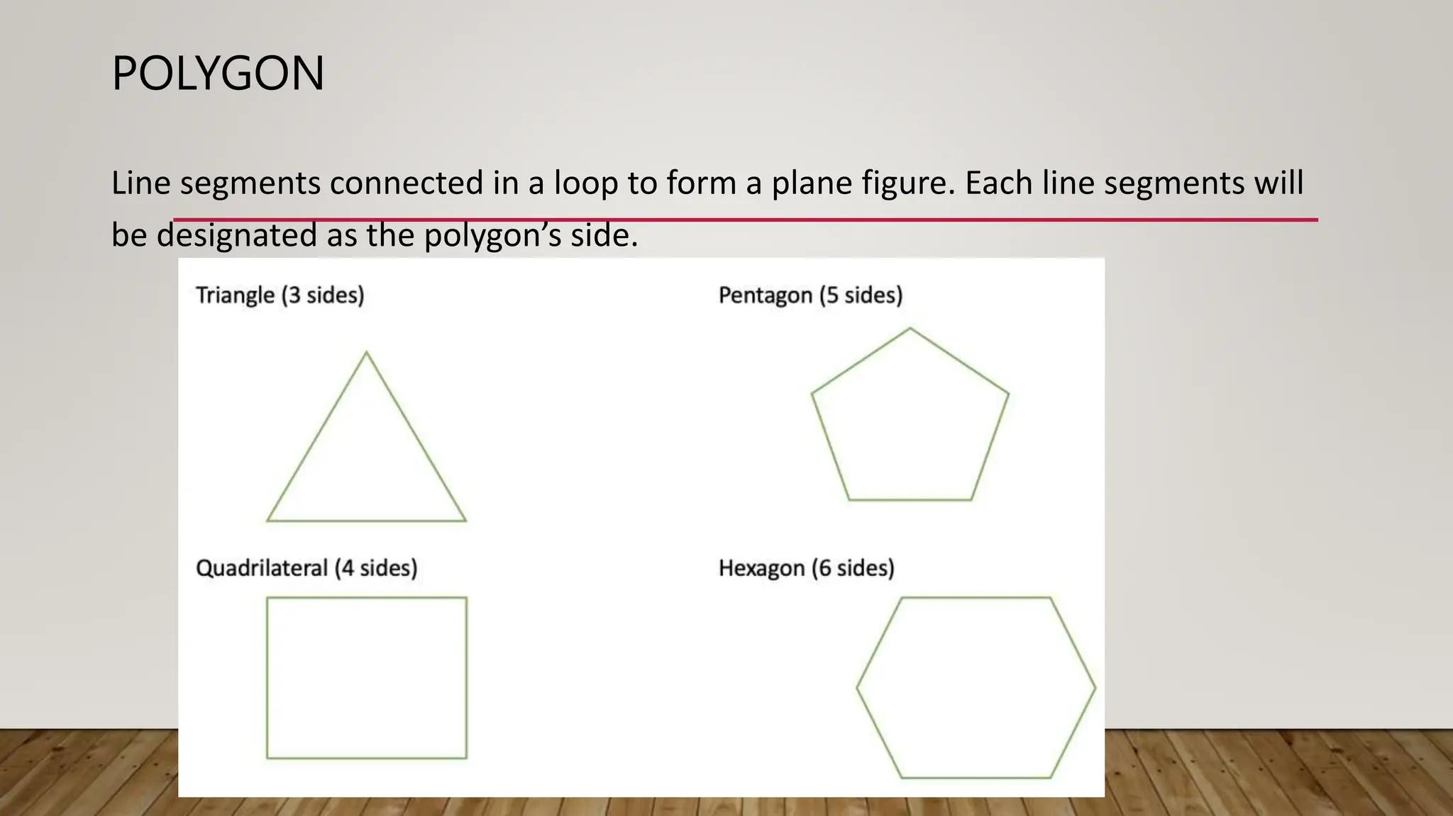
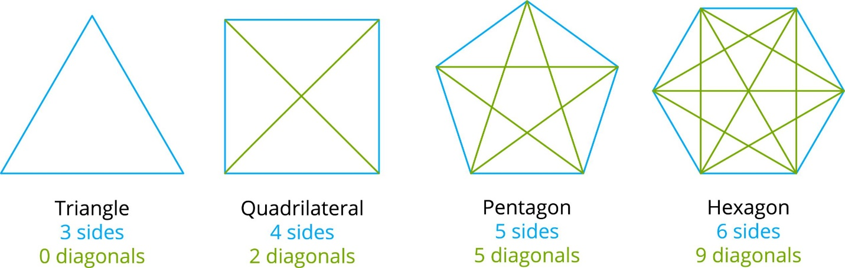
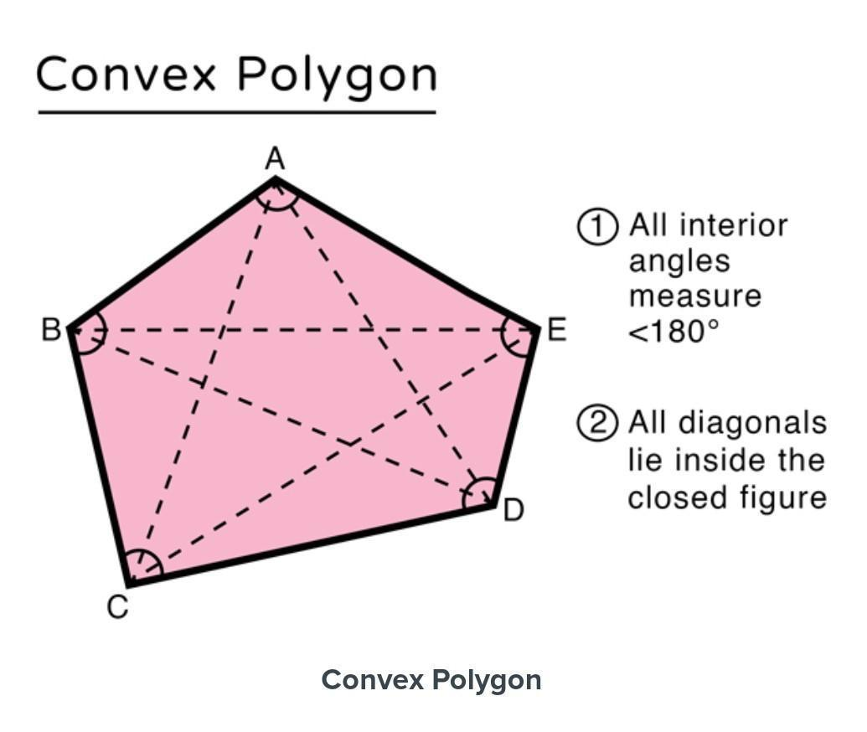
$$\boxed{0^{∘}<θ<{180}^{∘}}$$

Concave Closed Polygonal Shapes
# Source: AI Source: Provided by: [Data Path: Persons Table -> ID Column: 1, Name_En Column: Motasem Essam] -> From: [ChatGPT] on [7/25/2026]
At least one interior angle is greater than (180^\circ).
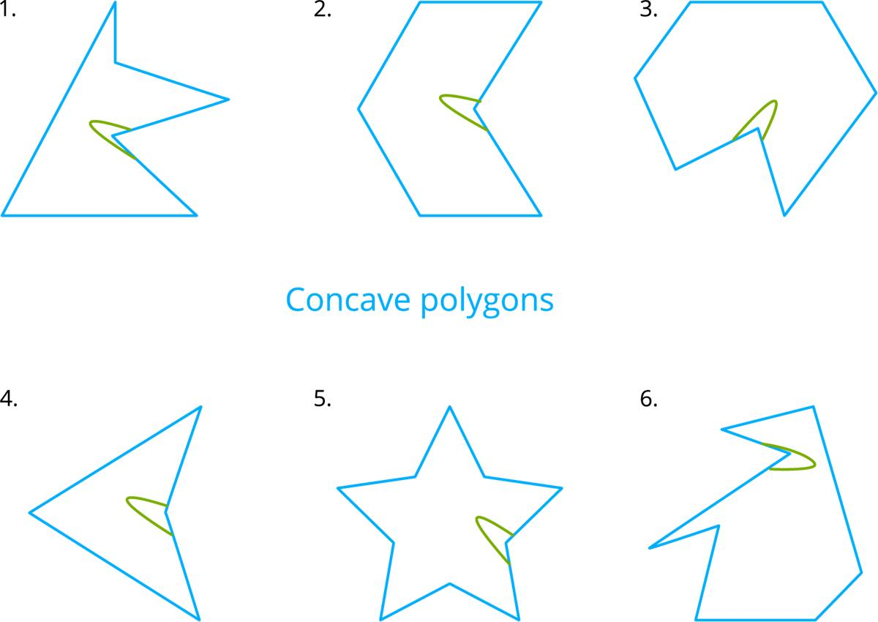
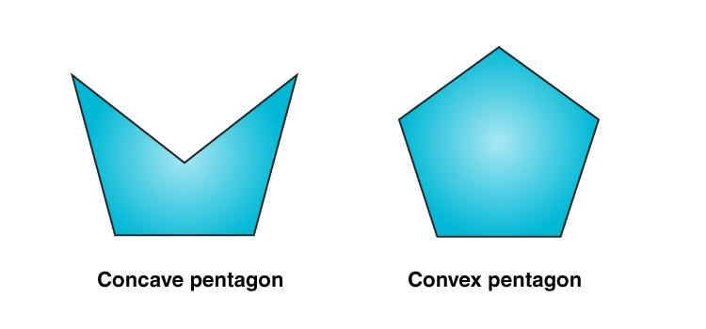
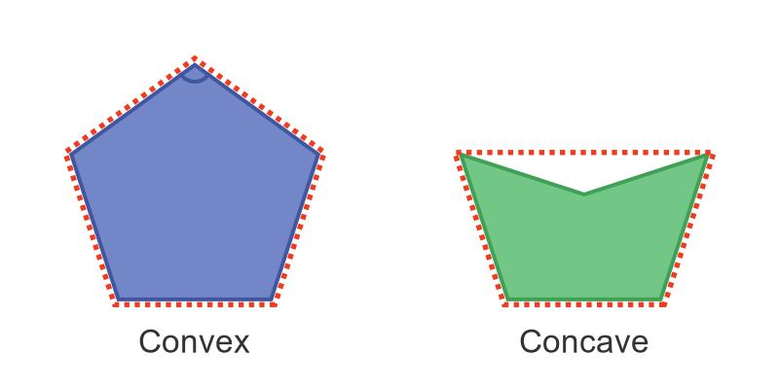
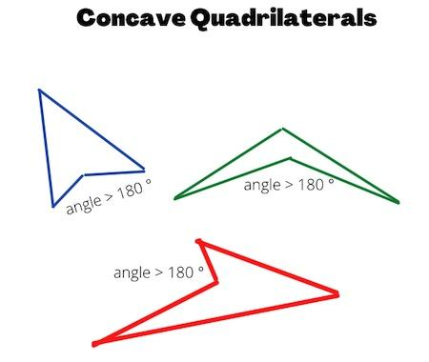
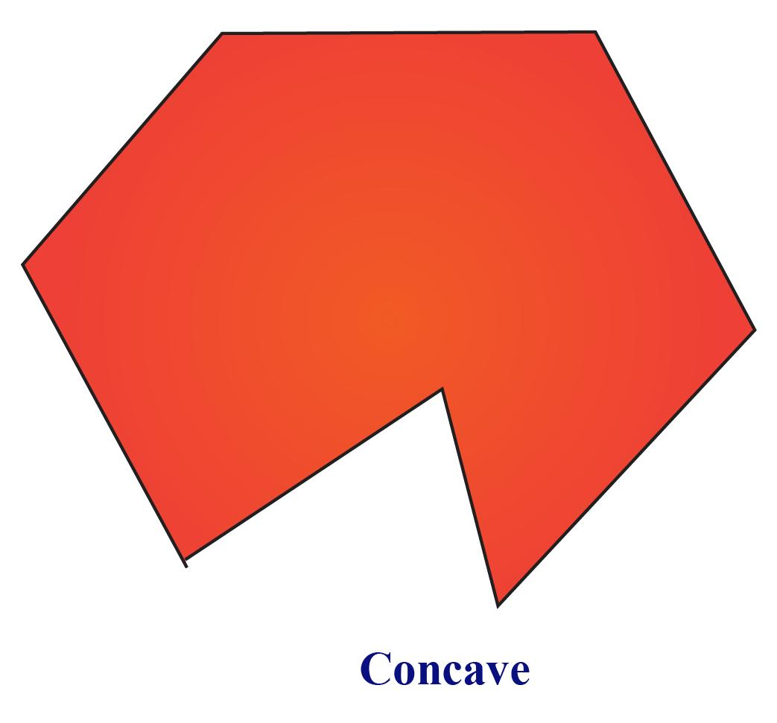
$$\boxed{∃θ>{180}^{∘}}$$

Boundary
# Source: AI Source: Provided by: [Data Path: Persons Table -> ID Column: 1, Name_En Column: Motasem Essam] -> From: [ChatGPT] on [7/25/2026]
The boundary of a closed polygonal shape is composed entirely of straight segments:
$$\boxed{∂R=\overline{P_{1}P_{2}}∪\overline{P_{2}P_{3}}∪⋯∪\overline{P_{n}P_{1}}}$$
The final segment connects the last vertex back to the first vertex:
$$P_{n}→P_{1}$$
This is what makes the polygon closed.

Interior and Exterior
# Source: AI Source: Provided by: [Data Path: Persons Table -> ID Column: 1, Name_En Column: Motasem Essam] -> From: [ChatGPT] on [7/25/2026]
Because the boundary is closed, it separates the plane into:
$$\boxed{\text{Interior Region}+\text{Boundary}+\text{Exterior Region}}$$
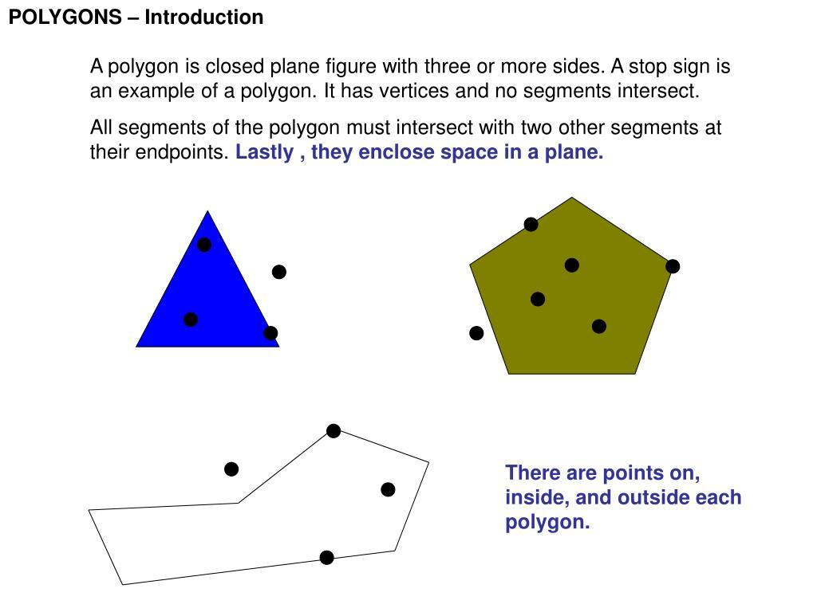
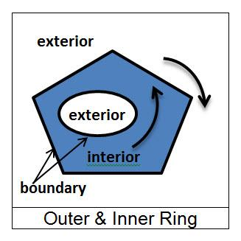
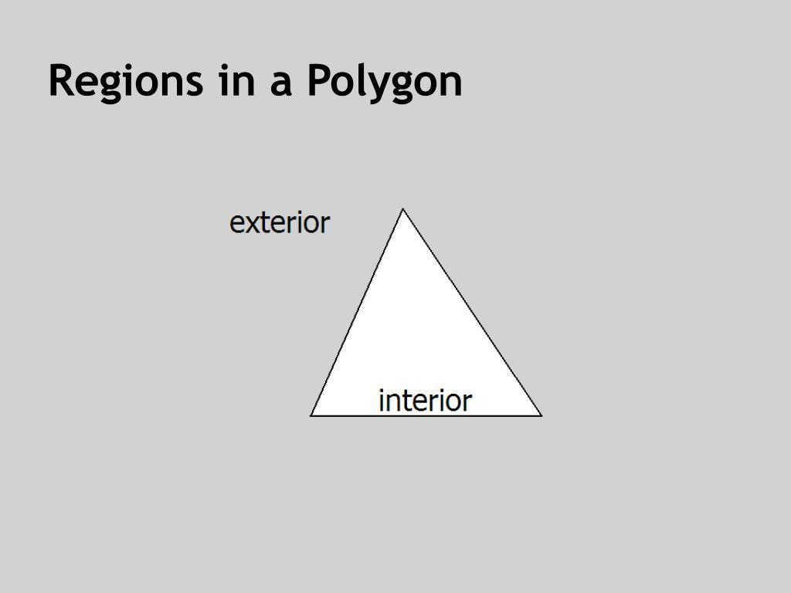
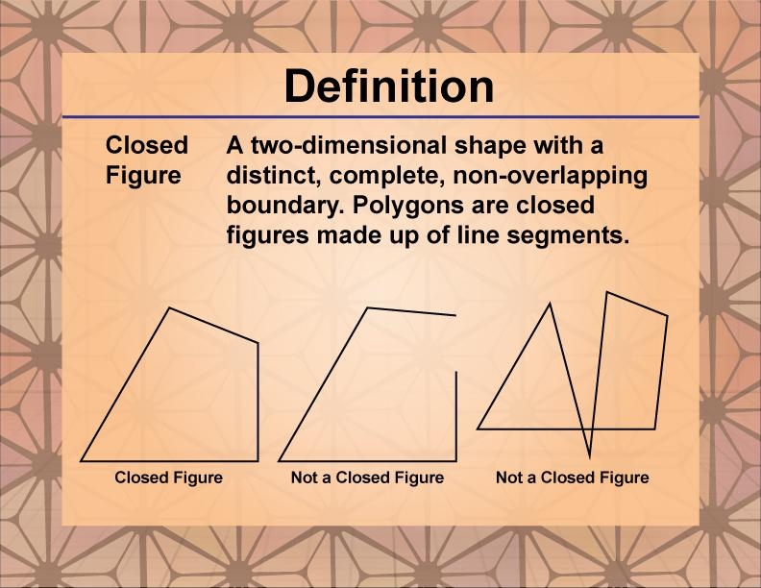
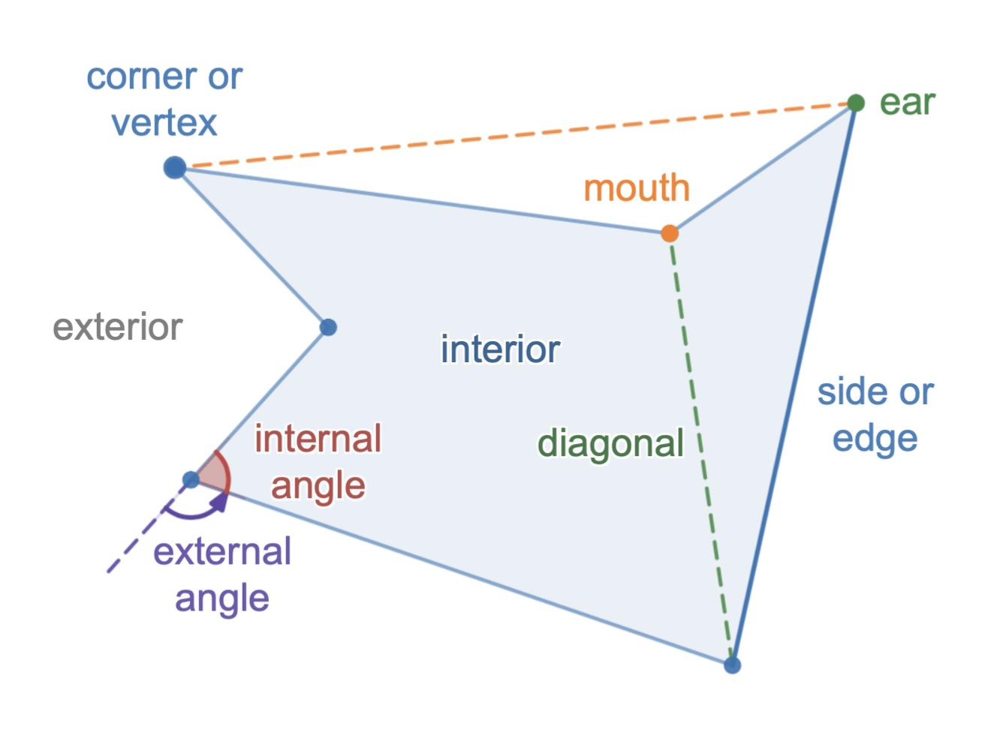

Perimeter
# Source: AI Source: Provided by: [Data Path: Persons Table -> ID Column: 1, Name_En Column: Motasem Essam] -> From: [ChatGPT] on [7/25/2026]
The perimeter is the total length of all sides:
$$\boxed{P=s_{1}+s_{2}+⋯+s_{n}}$$
For a regular polygon with side length $s$:
$$\boxed{P=ns}$$

Interior Angle Sum
# Source: AI Source: Provided by: [Data Path: Persons Table -> ID Column: 1, Name_En Column: Motasem Essam] -> From: [ChatGPT] on [7/25/2026]
For a polygon with $n$ sides:
$$\boxed{S=\left(n-2\right){180}^{∘}}$$
For example, a pentagon has:
$$S=\left(5-2\right){180}^{∘}={540}^{∘}$$

Area
# Source: AI Source: Provided by: [Data Path: Persons Table -> ID Column: 1, Name_En Column: Motasem Essam] -> From: [ChatGPT] on [7/25/2026]
A closed polygonal shape encloses a bounded area.
For some common polygons:
Rectangle
$$A=lw$$
Square
$$A=s^{2}$$
Triangle
$$A=\frac{1}{2}bh$$
For irregular polygons, the area can be calculated using decomposition or coordinate methods such as the shoelace formula.

Key Points
# Source: AI Source: Provided by: [Data Path: Persons Table -> ID Column: 1, Name_En Column: Motasem Essam] -> From: [ChatGPT] on [7/25/2026]
A Closed Polygonal Shape is:
$$\boxed{\text{Closed}+\text{Straight-Sided}+\text{Finite Number of Sides}}$$
It has:
- Straight boundaries only.
- Connected vertices.
- No open endpoints.
- A bounded interior region.
- An exterior region.
- A measurable perimeter.
- A measurable area.

Conclusion
# Source: AI Source: Provided by: [Data Path: Persons Table -> ID Column: 1, Name_En Column: Motasem Essam] -> From: [ChatGPT] on [7/25/2026]
Closed Polygonal Shapes are closed plane shapes formed entirely from straight line segments connected end-to-end. They include triangles, quadrilaterals, pentagons, hexagons, and polygons with any larger finite number of sides. They can be further classified by number of sides, regularity, and convexity, making them a fundamental category within Plane Geometry → Shapes → Closed Shapes.

